Formatting Numbers - Currency

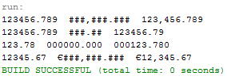

import java.text.DecimalFormat;
public class NumberFormatting {
private static void customFormat(String pattern, double value) {
DecimalFormat myFormatter = new DecimalFormat(pattern);
String output = myFormatter.format(value);
System.out.println(value + " " + pattern + " " + output);
}

public static void main(String[] args) {
customFormat("###,###.###", 123456.789);
customFormat("###.##", 123456.789);
customFormat("000000.000", 123.78);
customFormat("€###,###.###", 12345.67);
}
}

https://docs.oracle.com/javase/tutorial/java/data/numberformat.html

