onStart Method – Press ALT and INSERT keys simultaneously
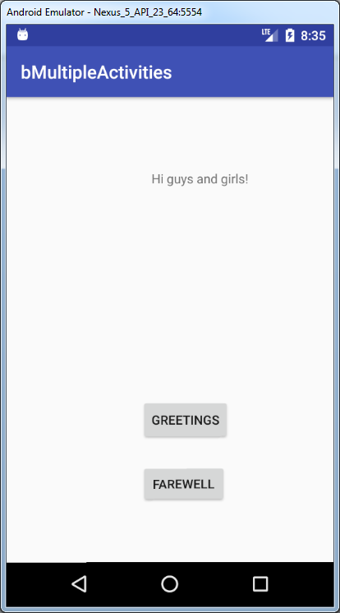
ckage com.raymundoconnor.bmultipleactivities;
import android.support.v7.app.AppCompatActivity;
import android.os.Bundle;
import android.view.View;
import android.widget.Button;
import android.widget.TextView;
public class MainActivity extends AppCompatActivity {
TextView tvMessage;
Button btnMessage;
Button btnFarewell;
@Override
protected void onStart() {
super.onStart();
btnMessage.setOnClickListener(new View.OnClickListener() {
@Override
public void onClick(View view) {
tvMessage.setText("Hi guys and girls!");
}
});
}
@Override
protected void onCreate(Bundle savedInstanceState) {
super.onCreate(savedInstanceState);
setContentView(R.layout.activity_main);
tvMessage = (TextView)findViewById(R.id.textViewMessage);
btnMessage = (Button)findViewById(R.id.buttonMessage);
btnFarewell=(Button)findViewById(R.id.buttonFarewell);
btnFarewell.setOnClickListener(new View.OnClickListener() {
@Override
public void onClick(View view) {
tvMessage.setText("Bye for now!");
}
});
}
}

