y=2x-4
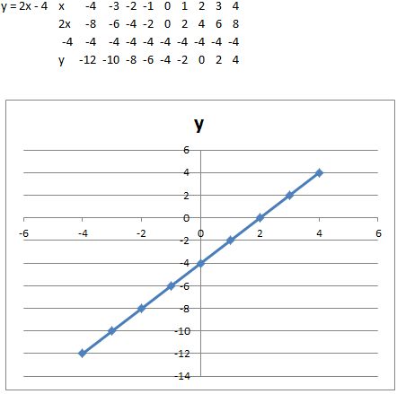

5x-2y=6
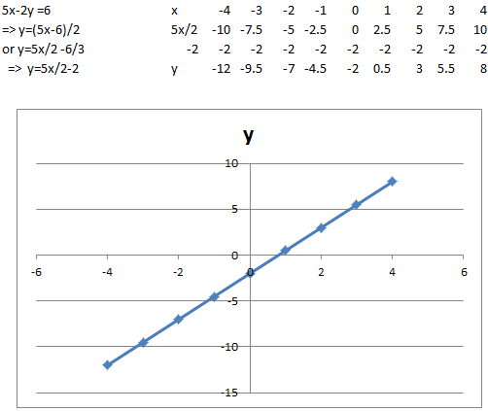

3x+4y-12=0

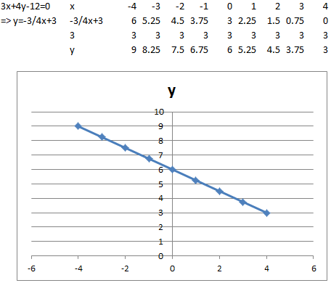

Formula
Midpoint of a line segment $\left(\frac{x_{1}+ x_{2}}{2} , \frac{y_{1}+ y_{2}}{2}\right)$
Equation of a line $y-y_{1}=m(x-x_{1})$
Slope of a line $y=mx+c$
Slope of a line given points on line $m=\frac{y_{2}- y_{1}}{x_{2}- x_{1}}$
Length of line segment or distance between 2 points $\sqrt{{(x_{2}-x_{1})}^{2}+{(y_{2}-y_{1})}^{2}}$
Parallel lines have the same slope $m_{1}=m_{2}$
Perpendicular lines slopes multiply to give -1 $m_{1}.m_{2}=-1$
Exercises
Find the Mid-point, Slope, Length of line segment and Equation of the lines for the following points
- $\left(-1, 1\right)$ and $\left(3, 4\right)$
- $\left(1, 2\right)$ and $\left(-2, 6\right)$

Perpendicular Lines
