Linear Programming Exercises
A company makes two products (X and Y) using two machines (A and B). Each unit of X that is produced requires 50 minutes processing time on machine A and 30 minutes processing time on machine B. Each unit of Y that is produced requires 24 minutes processing time on machine A and 33 minutes processing time on machine B. At the start of the current week there are 30 units of X and 90 units of Y in stock. Available processing time on machine A is forecast to be 40 hours and on machine B is forecast to be 35 hours.
The demand for X in the current week is forecast to be 75 units and for Y is forecast to be 95 units. Company policy is to maximise the combined sum of the units of X and the units of Y in stock at the end of the week.
Formulate the problem of deciding how much of each product to make in the current week as a linear program.Solve this linear program graphically.
Solution
Let
- x be the number of units of X produced in the current week
- y be the number of units of Y produced in the current week
then the constraints are:
- 50x + 24y <= 40(60) machine A time
- 30x + 33y <= 35(60) machine B time
- x >= 75 - 30
- i.e. x >= 45 so production of X >= demand (75) - initial stock (30), which ensures we meet demand
- y >= 95 - 90
- i.e. y >= 5 so production of Y >= demand (95) - initial stock (90), which ensures we meet demand
The objective is: maximise (x+30-75) + (y+90-95) = (x+y-50)
i.e. to maximise the number of units left in stock at the end of the week. It is plain from the diagram below that the maximum occurs at the intersection of x=45 and 50x + 24y = 2400
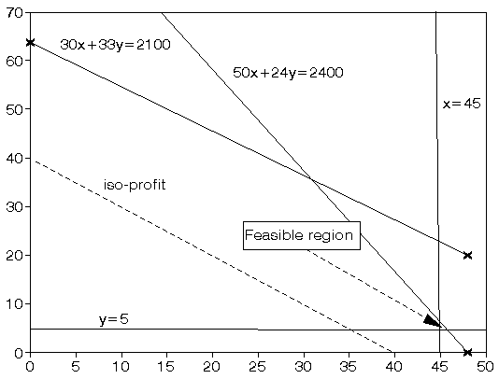
Solving simultaneously, rather than by reading values off the graph, we have that x=45 and y=6.25 with the value of the objective function being 1.25

