Exercise
Redraw the correct flowchart instead of the one given to represent the code below.
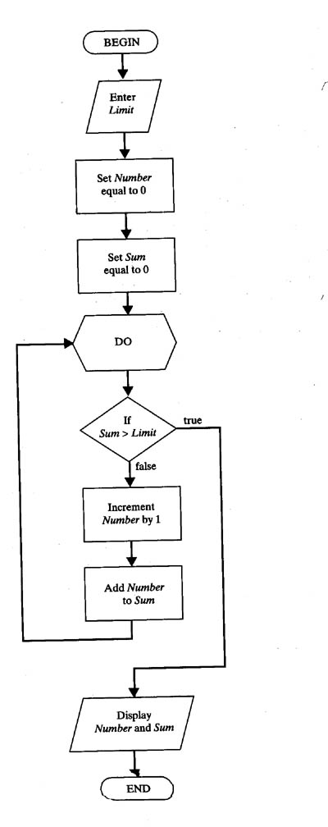
Source Code
import java.util.Scanner;
public class FlowChartProg {
public static void main(String[] args) {
// Code from Flow Chart
Scanner Input = new Scanner(System.in);
System.out.println("Enter Limit");
int Limit=Input.nextInt();
int Number = 0;
int Sum = 0;
do {
if(Sum < Limit){
Number++;
Sum+=Number;
System.out.println(Number);
}
} while (Sum < Limit);
System.out.println("Number = " + Number + "\t\tSum = " + Sum);
}
}

Output
