Gestures //to add override methods press ALT and INSERT keys simultaneously
Reference: https://developer.android.com/training/gestures/detector#java
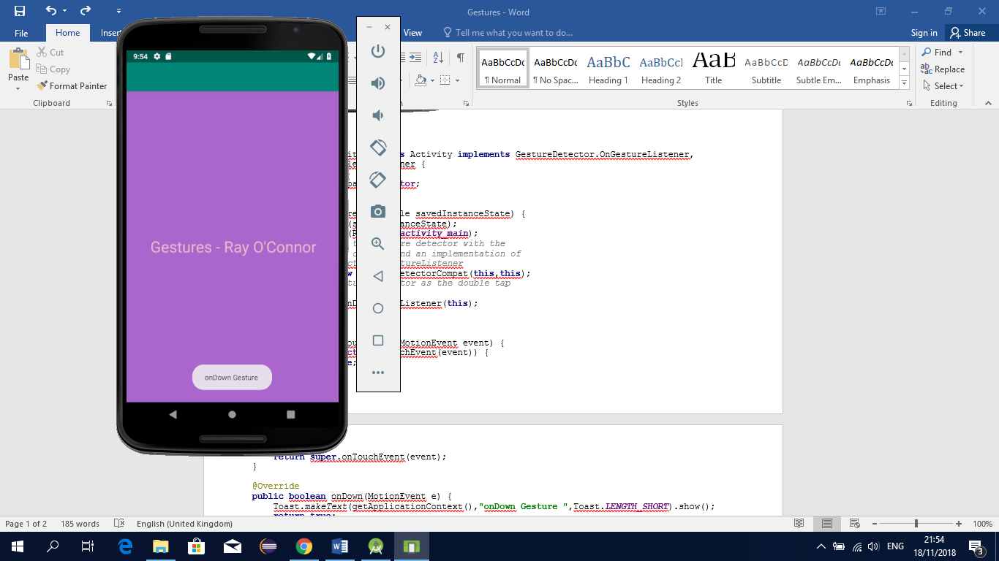
public class MainActivity extends Activity implements GestureDetector.OnGestureListener, GestureDetector.OnDoubleTapListener {
GestureDetectorCompat mDetector;
@Override
protected void onCreate(Bundle savedInstanceState) {
super.onCreate(savedInstanceState);
setContentView(R.layout.activity_main);
// Instantiate the gesture detector with the
// application context and an implementation of
// GestureDetector.OnGestureListener
mDetector = new GestureDetectorCompat(this,this);
// Set the gesture detector as the double tap
// listener.
mDetector.setOnDoubleTapListener(this);
}
@Override
public boolean onTouchEvent(MotionEvent event) {
if (this.mDetector.onTouchEvent(event)) {
return true;
}
return super.onTouchEvent(event);
}
@Override
public boolean onDown(MotionEvent e) {
Toast.makeText(getApplicationContext(),"onDown Gesture ",Toast.LENGTH_SHORT).show();
return true;
}
@Override
public void onShowPress(MotionEvent e) {
Toast.makeText(getApplicationContext(),"onShow Gesture ",Toast.LENGTH_SHORT).show();
}
@Override
public boolean onSingleTapUp(MotionEvent e) {
Toast.makeText(getApplicationContext(),"onSingleTap Gesture ",Toast.LENGTH_SHORT).show();
return true;
}
@Override
public boolean onScroll(MotionEvent e1, MotionEvent e2, float distanceX, float distanceY) {
return true;
}
@Override
public void onLongPress(MotionEvent e) {
Toast.makeText(getApplicationContext(),"onLongPress Gesture ",Toast.LENGTH_SHORT).show();
}
@Override
public boolean onFling(MotionEvent e1, MotionEvent e2, float velocityX, float velocityY) {
Toast.makeText(getApplicationContext(),"onFling Gesture ",Toast.LENGTH_SHORT).show();
return true;
}
@Override
public boolean onSingleTapConfirmed(MotionEvent e) {
return true;
}
@Override
public boolean onDoubleTap(MotionEvent e) {
return false;
}
@Override
public boolean onDoubleTapEvent(MotionEvent e) {
return true;
}
}

