Click Events
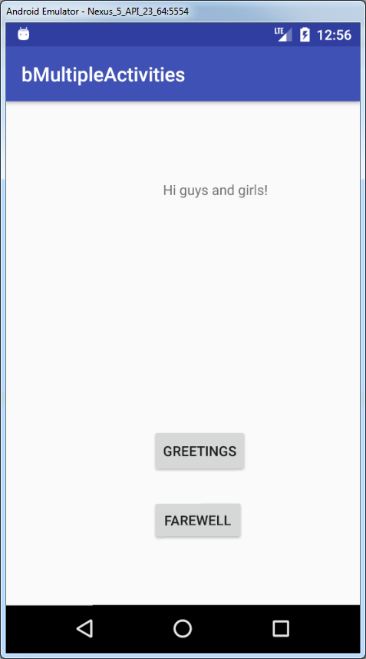

XML Code
<?xml version="1.0" encoding="utf-8"?>
<android.support.constraint.ConstraintLayout xmlns:android="http://schemas.android.com/apk/res/android"
xmlns:app="http://schemas.android.com/apk/res-auto"
xmlns:tools="http://schemas.android.com/tools"
android:layout_width="match_parent"
android:layout_height="match_parent"
tools:context="com.raymundoconnor.bmultipleactivities.MainActivity">
<TextView
android:id="@+id/textViewMessage"
android:layout_width="wrap_content"
android:layout_height="wrap_content"
android:layout_marginStart="160dp"
android:layout_marginTop="80dp"
app:layout_constraintStart_toStartOf="parent"
app:layout_constraintTop_toTopOf="parent" />
<Button
android:id="@+id/buttonMessage"
android:layout_width="wrap_content"
android:layout_height="wrap_content"
android:layout_marginStart="148dp"
android:layout_marginTop="232dp"
android:text="Greetings"
app:layout_constraintStart_toStartOf="parent"
app:layout_constraintTop_toBottomOf="@+id/textViewMessage" />
<Button
android:id="@+id/buttonFarewell"
android:layout_width="95dp"
android:layout_height="45dp"
android:layout_marginStart="148dp"
android:layout_marginTop="24dp"
android:text="Farewell"
app:layout_constraintStart_toStartOf="parent"
app:layout_constraintTop_toBottomOf="@+id/buttonMessage" />
</android.support.constraint.ConstraintLayout>

Java Code
package com.raymundoconnor.bmultipleactivities;
import android.support.v7.app.AppCompatActivity;
import android.os.Bundle;
import android.view.View;
import android.widget.Button;
import android.widget.TextView;
public class MainActivity extends AppCompatActivity {
@Override
protected void onCreate(Bundle savedInstanceState) {
super.onCreate(savedInstanceState);
setContentView(R.layout.activity_main);
final TextView tvMessage = (TextView)findViewById(R.id.textViewMessage);
Button btnMessage = (Button)findViewById(R.id.buttonMessage);
Button btnFarewell=(Button)findViewById(R.id.buttonFarewell);
btnMessage.setOnClickListener(new View.OnClickListener() {
@Override
public void onClick(View view) {
tvMessage.setText("Hi guys and girls!");
}
});
btnFarewell.setOnClickListener(new View.OnClickListener() {
@Override
public void onClick(View view) {
tvMessage.setText("Bye for now!");
}
});
}
}

