Madden’s Music Emporium

Flash Sale

Looking forward to hearing you play and then pay!!

Friday 26th June

9am to 9pm

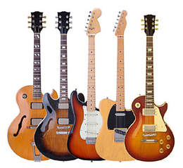

Jane Smith AS
Catalogue List
Name | Instrument | Lowest Price | Highest Price
Guild Granda X50 Late 50s Sunburst | Guitar | €837 | €1,209
Jackson Misha Mansoor Juggernaut BULB HT6 2015 Amber | Guitar | €2,326 | €2,698
Martin 00-21 Early ‘40s Natural | Guitar | €7,445 | €10,237
Seagull Artist Studio Concert Hall Element 2010s Sunburst | Guitar | €1,116 | €1,302
Fender Ron Emory Loyalty Parlor 2010s Sunburst | Guitar | €139 | €202
Fender Bassman Piggyback 1963 Blonde | Amp | €2,140 | €2,512
Fender Super 112 Combo 1990s Blackface | Amp | €325 | €372

