Madden’s Music Emporium

Flash Sale

Looking forward to hearing you play and then pay!!

Friday 26th June

9am to 9pm

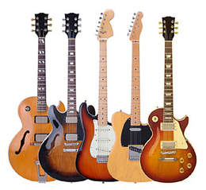

Jane Smith AS
Catalogue List
Name | Instrument Type | Type | Lowest Price | Highest Price
Guild Granda X50 Late 50s Sunburst | Guitar | Electric | €837 | €1,209
Jackson Misha Mansoor Juggernaut BULB HT6 2015 Amber | Guitar | Electric | €2,326 | €2,698
Martin 00-21 Early 40s Natural | Guitar | Acoustic | €7,445 | €10,237
Seagull Artist Studio Concert Hall Element 2010 Sunburst | Guitar | Acoustic | €1,116 | €1,302

