KEEPING ACTORS SAFE IN DANGEROUS SCENES
Actors can face specific risks on stages. There is no post-production; the spectator is in the same room, and the suspension of their disbelief depends on illusion rather than editing. Here we look at theatre practices for keeping workers safe.

Knives
Many theatres now ban the use of retractable blades, because they do not always retract on time. Instead, stage knives should have blunt, smooth blades and firm handles that can be gripped easily. Performers should use the same knife in every rehearsal and performance.

Other weapons
Theatre staff should treat every firearm as a lethal weapon, whether it is loaded or not. This includes guns that fire blanks. They should be locked away when not in use, and people who are nearby when they are used repeatedly, for example in rehearsals, should have appropriate ear protection for their hearing. In many countries, theatre staff inform the police before using a real or replica gun.
The Health and Safety Executive has published a guidance note, saying that a producer must assess the risks of scenes involving weapons in advance, and agree any controls needed with the actors and the crew.

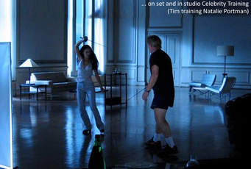

Hanging
The normal method for hanging scenes is a breakaway noose, where the noose is fake and actually lies quite loose around the actor's neck. Meanwhile, the actor is suspended from a harness.
This should be set up by someone with experience in rigging, and it should be supervised.

Fight scenes
Fight scenes on stage must:
- be choreographed by a fight director, who is consulted about any changes to costume or props
- be adequately rehearsed
- be conducted between performers who are capable of the fight's physical demands
- be run through before every performance

Bart Williams, who teaches stage combat in the US, told the BBC: "The actor needs to do the fight between eight and nine times a week. It's about rehearsing it so that you can preserve the illusion."

Planning ahead
Kevin Tanner, a technical director in Canada, says: "One of the most critical components of staging a production safely is the advance planning that should occur long before you arrive at the theatre.
"At the beginning of the artistic process for a production, the technical management should be developing a risk assessment that identifies potential hazards for the actors, artists and technicians, and identifies controls for those hazards.
"When it comes to actors, there is a huge trust in the production staff to ensure their safety." It is also normal for stage managers to produce a rehearsal report with all the details of every time the production meets. This could include information about choreographed scenes; for instance if a performer looks shaky in a scene, the director and fight choreographer will be told so that the scene can be re-worked.

What should the spectator see?
Nothing. Not the hook at the back of the noose, not the choreography. Everything should be believable.
Bart Williams says: "Ideally the spectator isn't going to be aware of any of it. If the spectator ever feels like it's unsafe, then it's wrong. The spectator wants to totally believe in the story.
"You want the illusion of danger but the spectator should only ever fear for the character's life, not the actor's."

