Basic App UI Design
Background Image – TextView – EditView- Button
You can toggle between Design and Text view (Design view below)
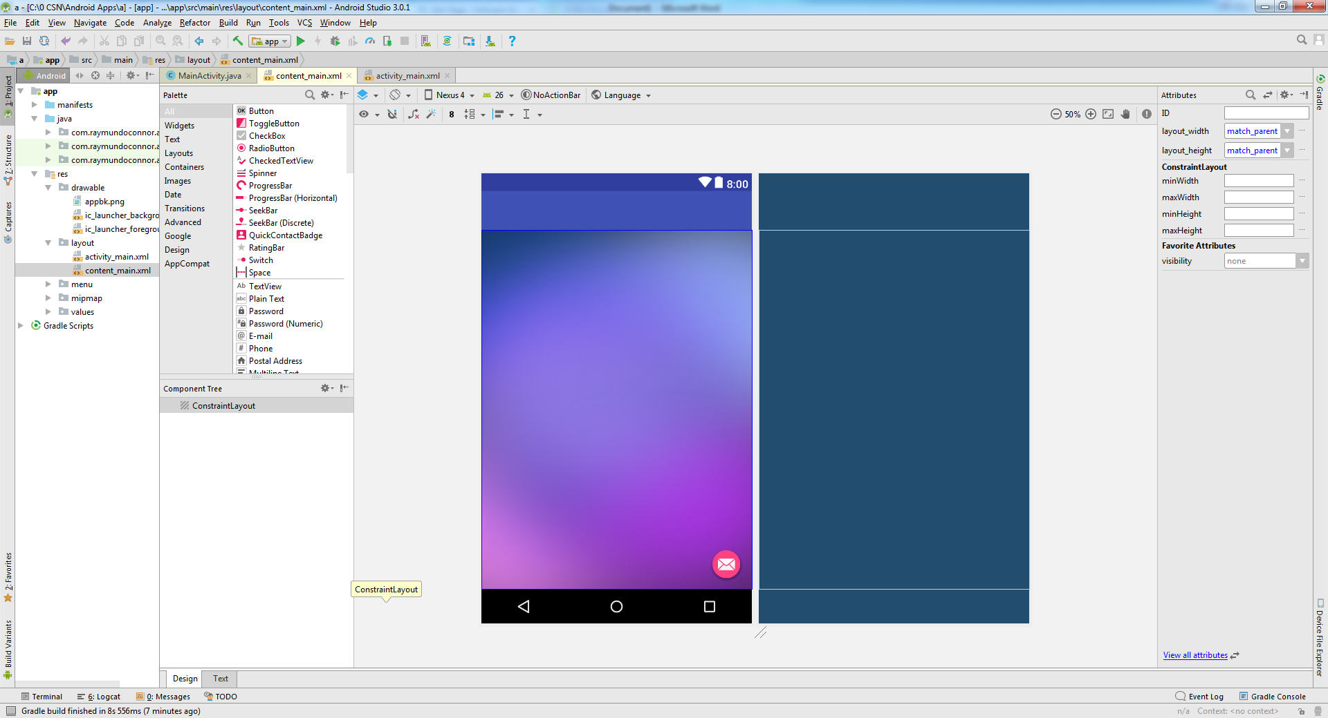
Text View
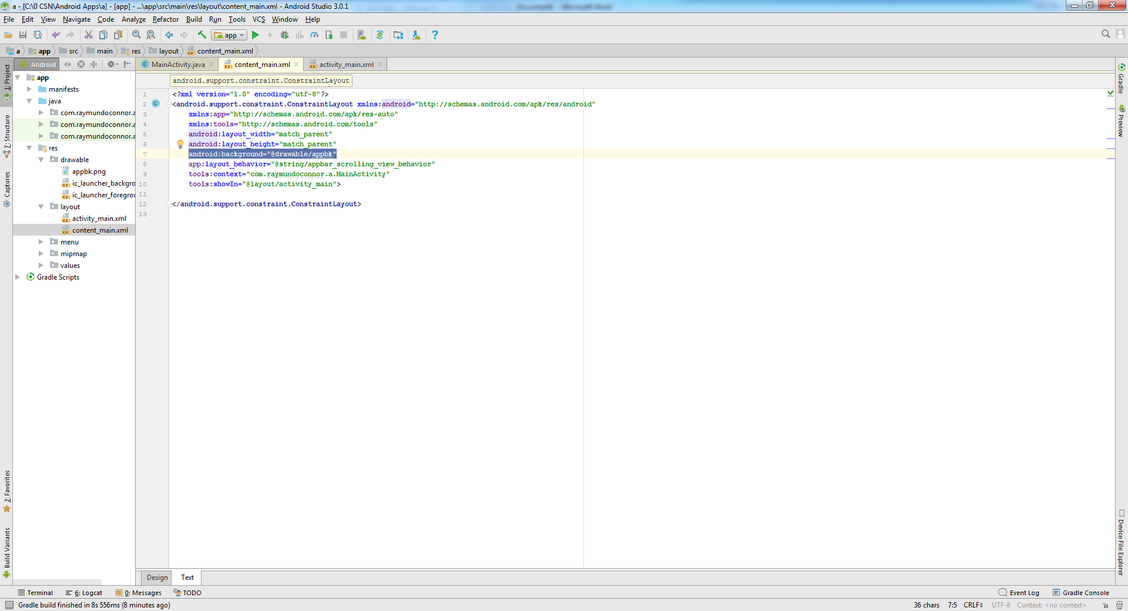
To set an image as background for our UI do the following:
- Copy you image (eg app_bk.png) and paste into the Drawable folder (right click on Drawable folder and paste)
- In Text view type the following line of code
  - android:background="@drawable/appbk"

