Weighted Mean
Formula
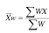

Example: Calculating grades
Suppose a class has quizzes, homework and three exams. The scores are weighted as follows:
Quiz | HW | Exam1 | Exam2 | Final
10% | 10% | 20% | 20% | 40%

Suppose your averages are as follows:
Quiz | HW | Exam1 | Exam2 | Final
80% | 89% | 79% | 84% | 87%

How is your grade calculated?
Multiply percentages by respective weights (written as decimals)
0.1(80)+0.1(89)+0.2(79)+0.2(84)+0.4(87)
= 84.3% final grade

Example: Price Increase
Type of Meat | Pork | Mutton | Beef | Poultry
% Price Increase | 2% | 8% | 3% | 5%

Mean Price Increase =

Type of Meat | Pork | Mutton | Beef | Poultry
% Price Increase | 2% | 8% | 3% | 5%
Weight | 3 | 1 | 4 | 2

Weighted Mean = %
Exercises
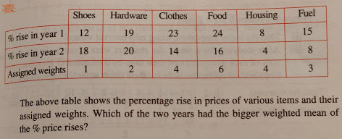
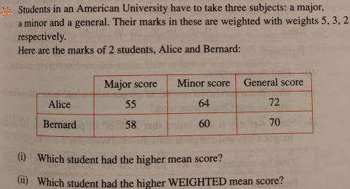

Answers
1
% rise in Year 1 | 12 | 38 | 92 | 144 | 32 | 45 | 18.15
% rise in Year 2 | 18 | 40 | 56 | 96 | 16 | 24 | 12.5
Year 1 Weighted Mean | 18.15
Year 2 Weighted Mean | 12.5

Answer = Year 1 has bigger weighted mean.

2
Weights | 5 | 3 | 2
 | Major | Minor | General |  |  |  |  |  | Sums
Alice | 55 | 64 | 72 |  | 275 | 192 | 144 | => | 611
Bernard | 58 | 60 | 70 |  | 290 | 180 | 140 | => | 610
Mean Scores
Alice | 63.67
Bernard | 62.67
Weighted Mean Scores
Alice | 61.1
Bernard | 61

- Alice has highest mean score
- Alice has highest weighted mean score.

