Example 1
Calculate the mean and standard deviation of the following:

9, 2, 5, 4, 12, 7, 8, 11, 9, 3, 7, 4, 12, 5, 4, 10, 9, 6, 9, 4
Mean (μ) = 9+2+5+4+12+7+8+11+9+3+7+4+12+5+4+10+9+6+9+420 = 140/20 = 7 Mean=7
=> 4, 25, 4, 9, 25, 0, 1, 16, 4, 16, 0, 9, 25, 4, 9, 9, 4, 1, 4, 9

= 4+25+4+9+25+0+1+16+4+16+0+9+25+4+9+9+4+1+4+9 = 178

Variance

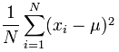 Variance = (1/20) × 178 = 8.9

Standard Deviation

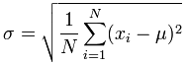 Standard Deviation σ = √(8.9) = 2.983

Example 2

Occurance(x):(in separated lines) Frequency of Occurance(f)
1 5
2 12
3 8
4 3
5 0
6 0
7 1

Occurance(X) | Frequency(f) | Freq*X | (X-mean) | (X-mean)2 | f*(X-mean)2
1 | 5 | 5 | -1.483 | 2.199 | 10.993
2 | 12 | 24 | -0.483 | 0.233 | 2.797
3 | 8 | 24 | 0.517 | 0.268 | 2.14
4 | 3 | 12 | 1.517 | 2.302 | 6.906
5 | 0 | 0 | 2.517 | 6.337 | 0
6 | 0 | 0 | 3.517 | 12.371 | 0
7 | 1 | 7 | 4.517 | 20.405 | 20.405
Total -> | 29 | 72 | - | - | 43.241
Mean = 2.483
Standard Deviation = 1.221
Variance = 1.491

Standard Deviation from list of numbers
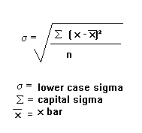

Standard Deviation from Frequency Distribution Table
