Relational Operators

Java has six relational operators that compare two numbers and return a boolean value. The relational operators are < , > , <= , >= , == , and !=.

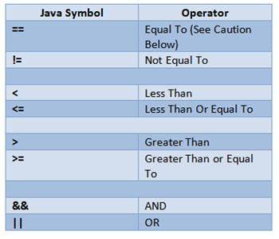

Source Code

// Type the following code and observe the output for each relational operator used

public static void main(String args[]) {
int a = 10;
int b = 20;
System.out.println("a == b = " + (a == b) );
System.out.println("a != b = " + (a != b) );
System.out.println("a > b = " + (a > b) );
System.out.println("a < b = " + (a < b) );
System.out.println("b >= a = " + (b >= a) );
System.out.println("b <= a = " + (b <= a) );
}

