Launch Eclipse

Click Help - Eclipse Marketplace - Scroll to JavaFX and click Install

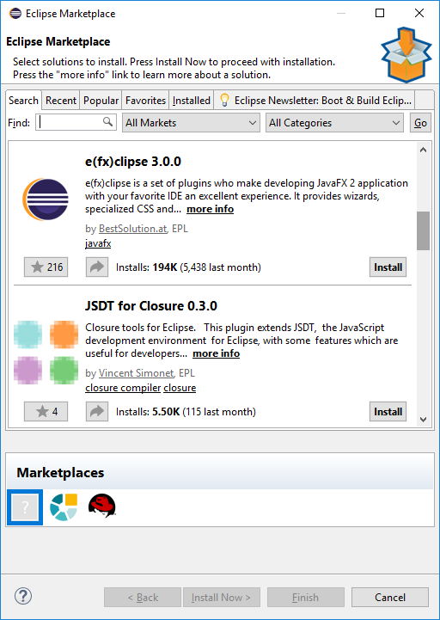

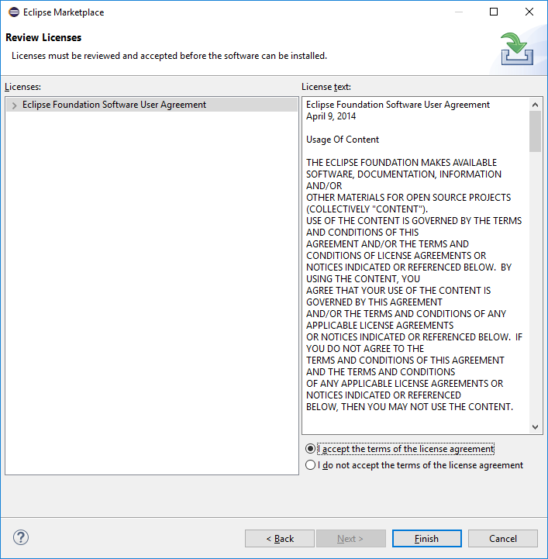
Click - I accept the terms radio button
Click - Finish

Click File and New Project and select JavaFX as shown below
