Histogram Exercise (Equal Widths)
The histogram below shows the efficiency level (in miles per gallons) of 110 cars.
a) How many cars have have an efficiency between 15 and 20 miles per gallon?
b) How many cars have have an efficiency more than 20 miles per gallon?
c) What percentage of cars have have an efficiency less than 20 miles per gallon?

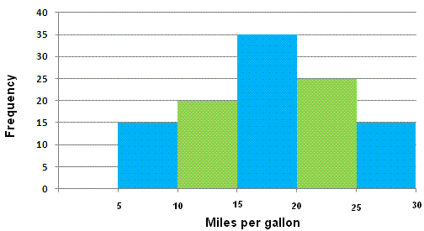

Solutions

a) 35 cars
b) 25 + 15 = 40 cars
c) (15 + 20 + 35) / 110 = 0.636 = 63.6%

Histogram with Different Widths Example
When constructing a histogram with non-uniform (unequal) class widths, we must ensure that the areas of the rectangles are proportional to the class frequencies.

Remember that the histogram differs from a bar chart in that it is the area of the bar that denotes the value, not the height. This means that we would need to consider the widths in order to determine the height of each rectangle.

Example
The following frequency distribution gives the masses of 48 objects measured to the nearest gram. Draw a histogram to illustrate the data.
Mass (g) | 10 – 19 | 20 – 24 | 25 – 34 | 35 – 50 | 51 – 55
Frequency | 6 | 4 | 12 | 18 | 8
Solution:
Evaluate each class widths.
Mass (g) | 10 – 19 | 20 – 24 | 25 – 34 | 35 – 50 | 51 – 55
Frequency | 6 | 4 | 12 | 18 | 8
Class width | 10 | 5 | 10 | 15 | 5

Since the class widths are not equal, we choose a convenient width as a standard and adjust the heights of the rectangles accordingly. We notice that the smallest width size is 5. We can choose 5 to be the standard width. The other widths are then multiples of the standard width.
The table below shows the calculations of the heights of the rectangles.
Mass (g) | 10 – 19 | 20 – 24 | 25 – 34 | 35 – 50 | 51 – 55
Frequency | 6 | 4 | 12 | 18 | 8
Class widths | 10 | 5 | 10 | 15 | 5
 | 2 × standard | standard | 2 × standard | 3 × standard | standard
Rectangle’s height in histogram | 6 ÷ 2 = 3 | 4 | 12 ÷ 2 = 6 | 18 ÷ 3 = 6 | 8

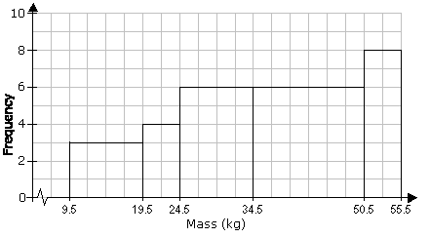

Pie Chart
When we represent data in a pie chart we must remember we are using 360 degrees.
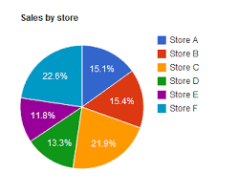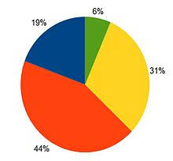

Example
Table: Favorite Type of Movie
Comedy | Action | Romance | Drama | SciFi
4 | 5 | 6 | 1 | 4

Comedy | Action | Romance | Drama | SciFi | TOTAL
4 | 5 | 6 | 1 | 4 | 20
20% | 25% | 30% | 5% | 20% | 100%
4/20 × 360°  = 72° | 5/20 × 360°  = 90° | 6/20 × 360°  = 108° | 1/20 × 360°  = 18° | 4/20 × 360°  = 72° | 360°
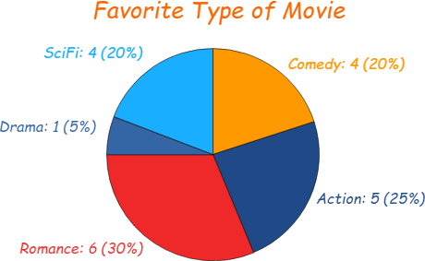

Bar Chart

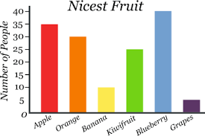

Trend Graph
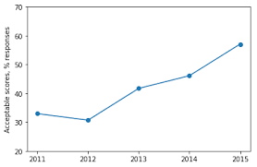

Exercise

Represent the following data of student grades in a pie chart, bar chart and trend graph.
A | B | C | D
4 | 12 | 10 | 2

