Data
Data is a collection of facts, such as numbers, words, measurements, observations or even just descriptions of things. Data can be Descriptive (like "high" or "fast") or Numerical (numbers). Numerical Data can be Discrete or Continuous:

Population - Sample Population
In stats, a sample is a part of a population. A population is a whole, it’s every member of a group. A population is the opposite to a sample, which is a fraction or percentage of a group. Sometimes it’s possible to survey every member of a group. A classic example is the Census in Ireland. Note: if you do manage to survey everyone, it actually is called a census:

Primary Data
Data observed or collected directly from first-hand experience. A survey or questionnaire you might organise.

Secondary Data
Published data and data collected in the past or by other parties is called secondary data. For example data gathered by the CSO (Central Statistics Office - www.cso.ie)
Qualitative vs Quantitative
Data can be qualitative or quantitative. Qualitative data is descriptive information (it describes something). Quantitative data is numerical information (numbers). Quantitative data can be Discrete or Continuous:

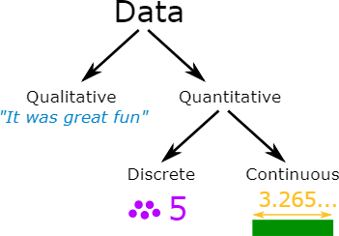

Discrete Data
Discrete Data can only take certain values. Discrete data is counted. Discrete data can only take certain values (like whole numbers)
Examples:
- The number of students in a class. We can't have half a student!
- The result of rolling a die - Only has the values 1, 2, 3, 4, 5 or 6

Continuous Data
Continuous data is measured. Continuous data can take any value (within a range)

Examples:
- A person's height: could be any value (within the range of human heights), not just certain fixed heights
- Time in a race: you could even measure it to fractions of a second
- A dog's weight
- The length of a leaf

