A Cumulative Frequency Graph is a graph plotted from a cumulative frequency table. A cumulative frequency graph is also called an ogive or cumulative frequency curve..
Example 1
Draw a cumulative frequency graph for the frequency table below.

Length (x mm) | Frequency
11 – 15 | 2
16 – 20 | 4
21 – 25 | 8
25 – 30 | 14
31 – 35 | 6
36 – 40 | 4
41 – 45 | 2

Solution
We need to add a class with 0 frequency before the first class and then find the upper boundary for each class interval.
Length  (x mm) | Frequency | Upper Class Boundary | Length  (x mm) | Cumulative  Frequency
6 – 10 | 0 | 10.5 | x ≤ 10.5 | 0
11 – 15 | 2 | 15.5 | x ≤ 15.5 | 2
16 – 20 | 4 | 20.5 | x ≤ 20.5 | 6
21 – 25 | 8 | 25.5 | x ≤ 25.5 | 14
25 – 30 | 14 | 30.5 | x ≤ 30.5 | 28
31 – 35 | 6 | 35.5 | x ≤ 35.5 | 34
36 – 40 | 4 | 40.5 | x ≤ 40.5 | 38
41 – 45 | 2 | 45.5 | x ≤ 45.5 | 40

And then plot the cumulative frequency against the upper class boundary of each interval and join the points with a smooth curve.

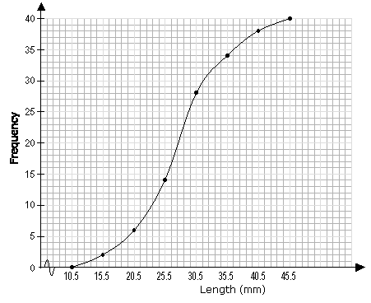

Example 2

Age (years) | Frequency
10 | 5
11 | 10
12 | 27
13 | 18
14 | 6
15 | 16
16 | 38
17 | 9
:
Age (years) | Frequency | Cumulative Frequency
10 | 5 | 5
11 | 10 | 5+10 = 15
12 | 27 | 15+27 = 42
13 | 18 | 42+18 = 60
14 | 6 | 60+6 = 66
15 | 16 | 66+16 = 82
16 | 38 | 82+38 = 120
17 | 9 | 120+9 = 129

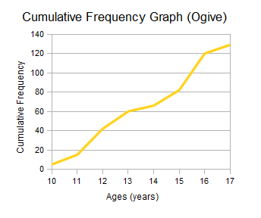
Exam Results Example - Cumulative Frequency Curve (Ogive)
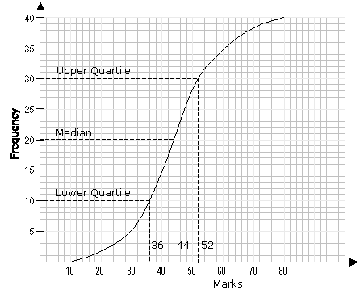

Percentile
A percentile is a certain percentage of a set of data.

Median
The median corresponds to the 50th percentile i.e. 50% of the total frequency.
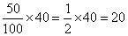
From the graph, 20 on the vertical axis corresponds to 44 on the horizontal axis. The median mark is 44.

Upper Quartile
The upper quartile corresponds to the 75th percentile i.e. 75% of the total frequency.
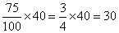

From the graph, 30 on the vertical axis corresponds to 52 on the horizontal axis. The upper quartile is 52.

Lower Quartile
The lower quartile corresponds to the 25th percentile i.e. 25% of the total frequency.
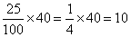
From the graph, 10 on the vertical axis corresponds to 36 on the horizontal axis. The lower quartile is 36.

Inter Quartile Range

Upper - Lower Quartile = 52 - 36 = 16

