Exercise

Write java source code which generates stores and outputs 10 random numbers.

Output

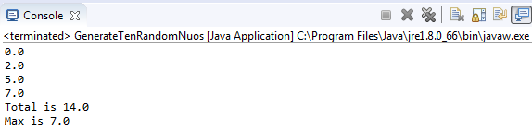

Source Code

import java.util.*;
public class GenerateTenRandomNuos {

public static void main(String[] args) {
// TODO Auto-generated method stub
double[] arrNumbers = {2.1, 2.5, 5.05, 7.25};
// Print all the array elements
for (int i = 0; i < arrNumbers.length; i++) {

Random RandNum = new Random();
int GenNum = RandNum.nextInt(10); // generates random num 0 to 10
arrNumbers[i]=GenNum;
System.out.println(arrNumbers[i] + " ");
}
// Summing all elements
double total = 0;
for (int i = 0; i < arrNumbers.length; i++) {
total += arrNumbers[i];
}
System.out.println("Total is " + total);
// Finding the largest element
double max = arrNumbers[0];
for (int i = 1; i < arrNumbers.length; i++) {
if (arrNumbers[i] > max) max = arrNumbers[i];
}
System.out.println("Max is " + max);
}
}

