Tabular Work and Footnotes
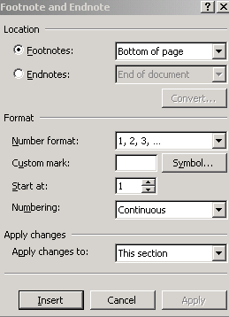
- Here we need to align figures so will use a different type of tab stop
- Insert a Footnote to accommodate the C and F explanations at the foot of the page. To place a Footnote click on Insert/Reference/Footnote
- The footnote symbol must be chosen from the dialog you see here. To use an asterisk change the Number format until you see the asterisk. The system will automatically change the symbol for second and subsequent footnotes on the same page
- Use 1½ line spacing for body of work
- Use typeface Franklin Gothic Book. For the heading use size 14, small caps. For the remainder of the document use size 12, regular
- Save as Temperatures to your CSN drive in the WP folder

This is the exercise to type. Set the tab stops where you think appropriate. Use decimal tabs or right-aligned tabs for the C and F columns

_________________________________________________________________________

Yesterday's Midday Temperatures

C* F♦
Brussels Rain 9 48
Amsterdam Fair 6 43
Barcelona Cloudy 15 59
Geneva Fair 7 45
Biarritz Clear 11 63
Copenhagen Sunny 7 45
Cork Sunny 5 41
Luxemburg Cloudy 10 46
London Thunder 7 45
Moscow Snow 8 46
Rome Rain 13 55
Vancouver Clear 16 61
Warsaw Sleet 13 55

* Celcius
♦ Fahrenheit

