Word Processing – Microsoft Word
Toolbar
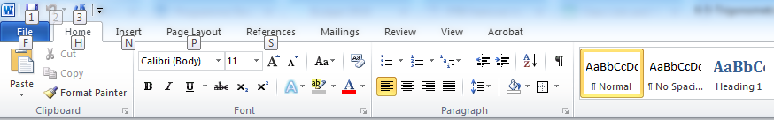
Explain each icon on toolbar.

Full Toolbar

