
Word Exercise 4. Table Exercise
For this exercise you will need to know how to: Inserting a table; Merging Cells; Shading Cells; Changing Cell/Table borders
Scenario: You are going to create a simple Registration Form

Creating and Formatting Tables

First Attempt(!)
Open Word and start a new document. Set the font to Arial and point size 14.
Insert a table with 2 columns and 6 rows.
In the left hand column put the following items into the six cells:
Surname
Other Names
Date of Birth
Address
Postcode
Telephone Number
Make all these items right aligned.
Resize the form so that there is room to write in the boxes, for example add three lines to the cell containing the word Address.
We want to add a title to this form, insert a new row above the first row.
Merge the top two cells and type into that cell Registration Form, format this title so that is Arial point size 40, bold and centred in the cell.
To make the title stand out, set the shading in this cell to be 25% Grey.
To show that the information is to written in the right hand columns, set the shading of the left hand column to 25% grey as well.
Make the outer border thicker than the inner lines.
The table should now look like this:
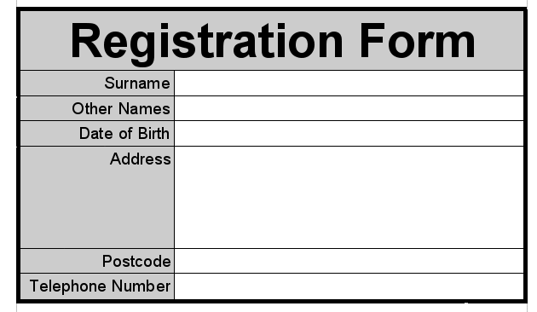

Final Version
That form is usable but nothing special. We'll now use the same techniques to create a form which looks a lot more professional.
Below the table add a few blank lines and insert a table with 4 columns and 8 rows.
Merge the top four cells and add the text Registration Form, format this to Arial point size 40, bold and centred.
Add the item names as before into the left hand column. Make them right aligned.
Merge the bottom four cells and add the text Please complete all the boxes. Format this to Arial point size 10, italic and centred.
Using Grey 25% shade the top row, the left hand column, the bottom row and the right hand column.
The “trick” is now to set the outer border to thick black lines and the inner lines to thick 25% grey lines. The form looks better if the inner lines are much thicker than the outer lines.
Adjust the columns widths and add some more shading (in the third column) so that your table looks similar to the table below.
You may want to change the top and bottom row heights to give the text in those rows a little more space.
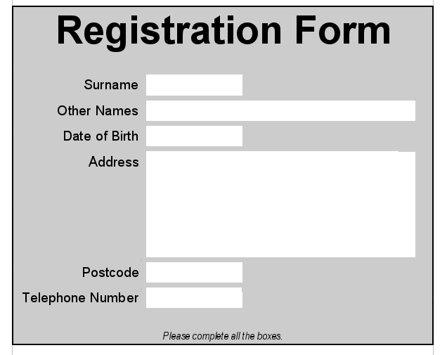
Add a footer which contains your Name on the left and the Date on the right.
Save the document containing the two forms/tables as word exercise 4 or a similar name.

©Copyright School of Computing, University of Glamorgan
If you have any problems or queries regarding these pages, please contact Ray Kingdon
Last Updated: 12 Aug 2003

