Microsoft Word: Exercise 9- Tables

In this exercise you will practice:

- Creating a table
- Changing the Margin size
- Changing the page Orientation
- Navigating and using tools on different tabs
- Using Save and Save As
- Copying and pasting between documents


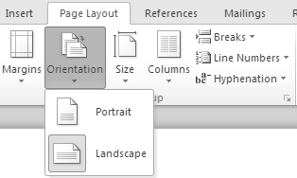
- Open a new Microsoft Word document by double-clicking the icon on the desktop.

- On the Ribbon, click the Page Layout tab. In the Page Setup group, click Orientation. Two options should appear.

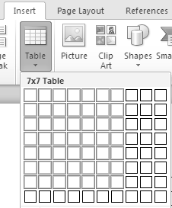
- Click Landscape. This will change the direction the document will print on a piece of paper. Portrait orientation prints the document vertically. Landscape orientation prints the document horizontally.

- On the Ribbon, click the Insert tab. In the Tables group, click Table. A menu with little squares should appear.

- Move the cursor over squares until the top of the menu shows 7x7 Table and then click. This tells Microsoft Word you want a table with 7 rows and 7 columns. The table should appear in your document.

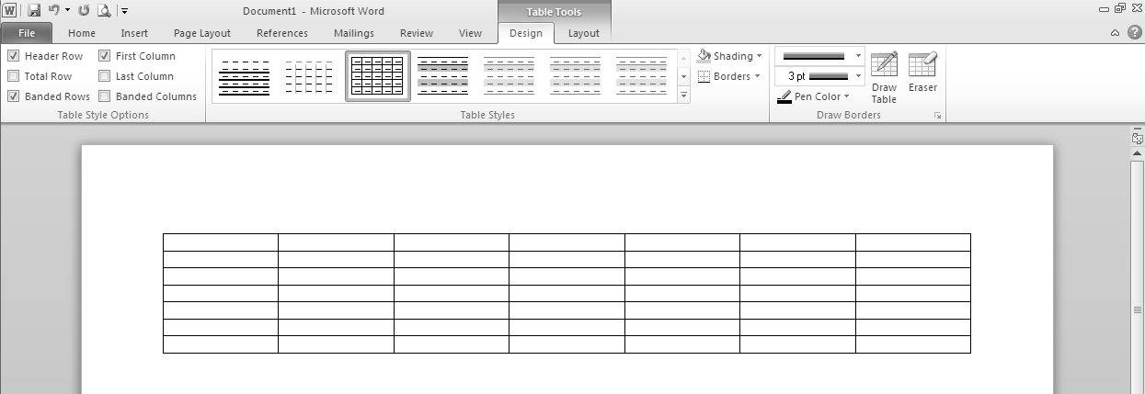
- Your document should look like the picture below. Notice that 2 new tabs, Design and Layout, appeared on the Ribbon.

- Click in the cell in the top left corner of the table, you should see your cursor flashing there. Each box that is part of your table is called a cell.

- Type: April

- Click in the cell below April. Type: Sunday

- Press the Tab Key on the keyboard. This will move the cursor to the next cell. Type: Monday

- Use the Tab key to type Tuesday, Wednesday, Thursday, Friday, and Saturday in the next 5 cells.

- Click in the cell below Tuesday. You should see your cursor flashing there. Type: 1

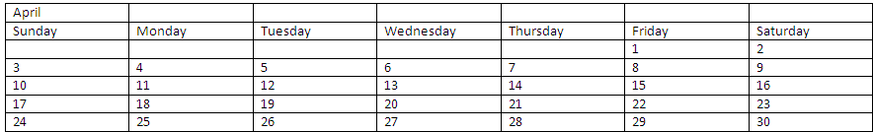
- Use the Tab key to fill in the rest of the calendar dates like the picture below. Pressing Tab at the end of a row will automatically bring you down to the first cell in the next row.

- On the Home tab in the Editing group, click Select and then click Select All to highlight the entire table.

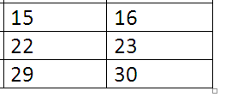
- Change the font size to 20, and then click before the word April to clear the highlighting. Look in the Font group to find the Font Size dropdown menu.

- Hold your cursor over the table and look for the little white square in the bottom right corner. Move the cursor over the white square, and it should look like a double-pointed arrow. The arrow allows you to change the size of the table.

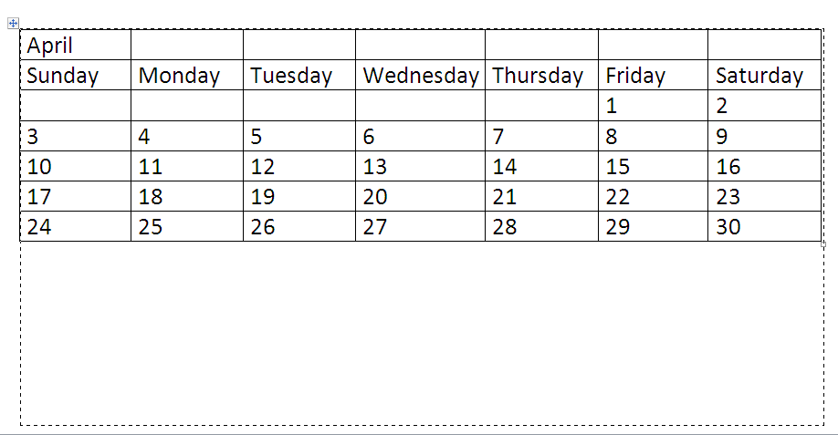
- Click the square and drag straight down. You should see a dotted line showing the size the table will be when you let go of the mouse button.

- Make the table bigger until the bottom row is near the bottom of the page. You may need to click and drag several times.

- Highlight the top row of cells.

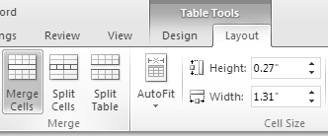
- On the Layout tab, in the Merge group, click Merge Cells. This will combine all the columns in the top row into one for the title.

- Keep the top row highlighted and then Center the text, change the font size to 48 and change the font to Tempus Sans ITC. Click the Home tab to find the tools you need.
- Hold your cursor over the line below Wednesday. The cursor should change to look like this: This cursor allows you to change the cell height.

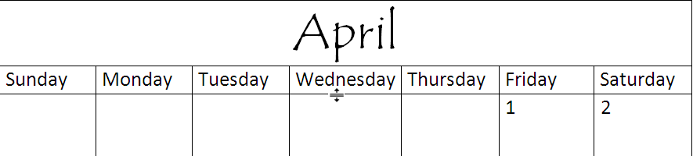
- Click and drag up until there is very little white space below the days of the week.

- Highlight the top row of the table.

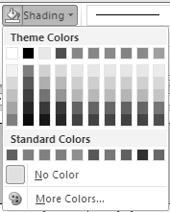
- On the Design tab in the Table Styles group, click Shading to show a menu of colors you can choose to shade your table.

- Click a green square. The background of the top row should be green. You will need to click to clear the highlighting to see the color of the row.

- Highlight the second row of the table. This is the row with the days of the week.

- In the Table Styles group, click Shading to show the menu of colors. Click a light green square. The background of the second row should be light green.

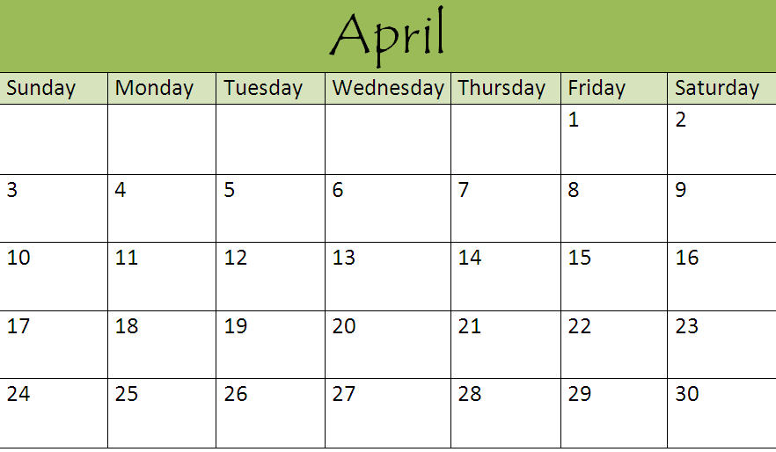
- On the Ribbon, click the File tab to open the Backstage View. Click Print to look at a print preview of the document. It should look like this:

- On the left side of the window click Save. A box will appear.

- Name the document
April 2011 Calendar.

- Save the document to your flash drive or to the My Documents folder. Use the Save in dropdown menu at the top of the box or the icons on the left side of the box to choose where you want to save the file.

- Click Save in the bottom right corner of the box.

- Click in the white space below the table. You should see the cursor flashing there. If you have no space below your table, make the table smaller by clicking and dragging the white square in the bottom right corner of the table.
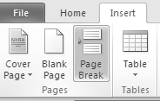
- On the Ribbon, click the Insert tab. In the Pages group click Page Break. The cursor should be flashing at the top of page 2.

- Minimize the document using the Minimize command in the top right corner of the window. You should see the Desktop. If you do not see the Desktop, then minimize the other windows you have open.

- Open the My Documents folder by double clicking on the icon.

- Open the Word document CelebratingApril by double clicking on the icon.

- On the Home tab in the Editing group, click Select and then click Select All to highlight all the text in the document.

- In the Clipboard group, click the Copy command to tell Microsoft Word to remember what is highlighted.

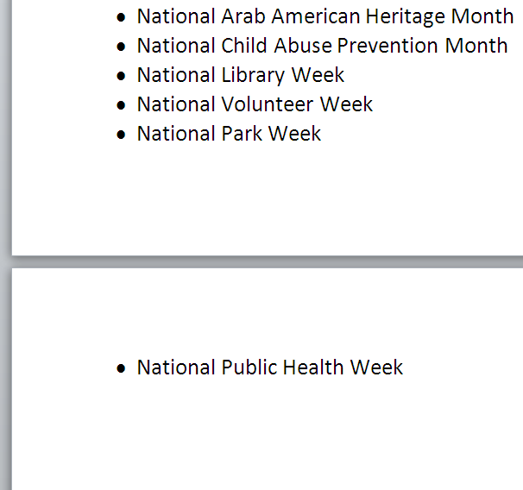
- At the bottom of the screen, in the Taskbar, click the box that says April2011Calendar.docx and the calendar document you created should appear.

- Make sure the cursor is still flashing at the top of page 2, and then click the Paste command. The Paste command is located on the Home tab in the Clipboard group. The text you copied from the CelebratingApril document should appear.

- Scroll up and down to see the entire document. There should be 3 pages. There is a little grey space between each page.

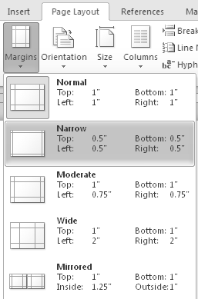
- Look at page 3. There is only one bullet point on page 3. It would be better to have the last bullet point with the rest of the list on page 2.

- On the Ribbon, click the Page Layout tab. In the Page Setup group, click Margins to show a list of margin options.

- Click the Narrow option, which has the top, bottom, left and right margins set to .5”. The Narrow margin setting makes the margins smaller and allows more text to fit on the page.

- Scroll up and down to see the entire document. There should be 2 pages. The last bullet point should be on page 2.

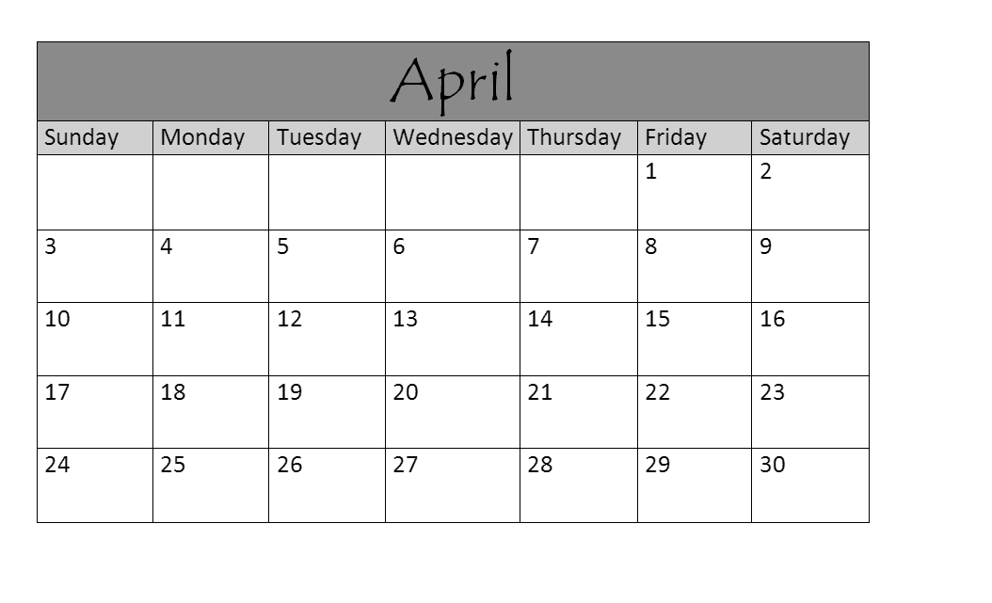
- The document should look like this:

- On the Ribbon, click the File tab.

- On the left side of the window click Save As. A box will appear.

- Change the name of the document to CelebrateApril2014.

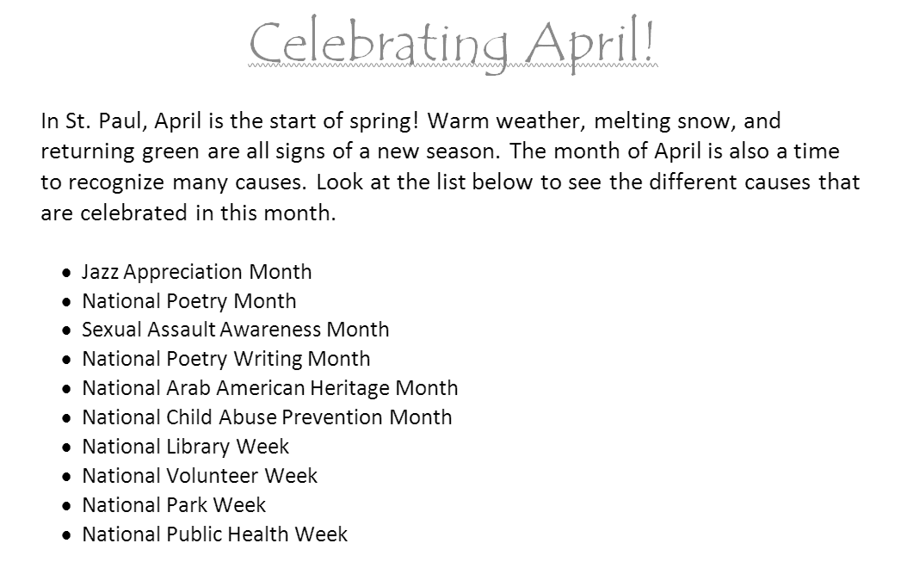
- Save the document to your flash drive or to the My Documents folder. Use the Save in dropdown menu at the top of the box or the icons on the left side of the box to choose where you want to save the file.

- Click Save in the bottom right corner of the box.

- Click the X in the top right corner of the window to close the document. You will need to close the CelebratingApril document too.

- Find the icons for the 2 files you created: April2014Calendar and CelebrateApril2014. They should be saved in the My Documents folder or on your flash drive.

