Skills Demo 1 Ray O’Connor 20/9/2018
Rename Router |  | Rename Smart Device
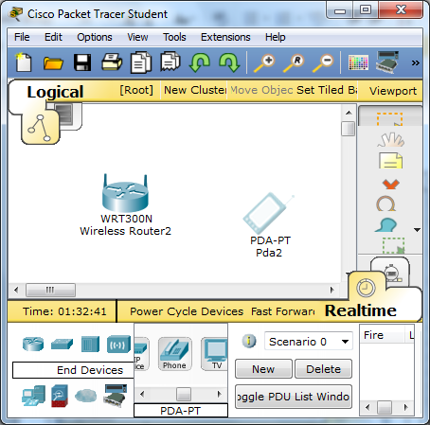  On the Insert tab, the galleries include items that are designed to coordinate with the overall look of your document. You can use these galleries to insert tables, headers, footers, lists, cover pages, and other document building blocks. When you create pictures, charts, or diagrams, they also coordinate with your current document look. |  | 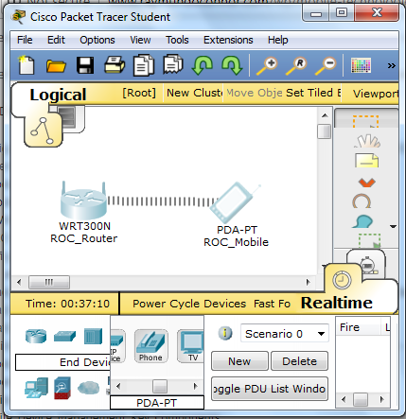  On the Insert tab, the galleries include items that are designed to coordinate with the overall look of your document. You can use these galleries to insert tables, headers, footers, lists, cover pages, and other document building blocks. When you create pictures, charts, or diagrams, they also coordinate with your current document look.
MAC Address Filtering Settings |  | MAC Address with Smart device filtered
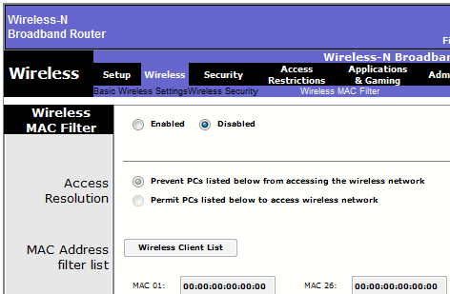  On the Insert tab, the galleries include items that are designed to coordinate with the overall look of your document. You can use these galleries to insert tables, headers, footers, lists, cover pages, and other document building blocks. When you create pictures, charts, or diagrams, they also coordinate with your current document look. |  | 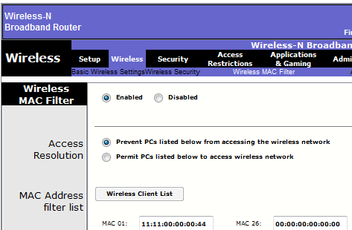  On the Insert tab, the galleries include items that are designed to coordinate with the overall look of your document. You can use these galleries to insert tables, headers, footers, lists, cover pages, and other document building blocks. When you create pictures, charts, or diagrams, they also coordinate with your current document look.

00:90:21:7D:B8:40

