Exercise

Write java source code which allows the user guess a number 0 to 10, the computer will then generate a random number and output if you chose the same number or not.

Test Data

6 and 7

Output
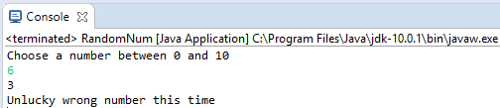
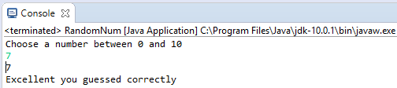

Source Code

import java.util.*;
public class RandomNum {
public static void main(String[] args) {
/* Random number generator ensure you import java.util.* in the past
* we imported Scanner class but we use * so Random class is imported */
Scanner InputNum = new Scanner(System.in);
System.out.println("Choose a number between 0 and 10");
int MyNum = InputNum.nextInt();
Random RandNum = new Random();
int GenNum = RandNum.nextInt(10); // generates random num 0 to 10
System.out.println(GenNum);
if (MyNum==GenNum) {
System.out.println("Excellent you guessed correctly");
} else {
System.out.println("Unlucky wrong number this time");
}
}
}

