Guidelines:

Brill Bicycle Hire rents bicycles with pricing as shown in the table underneath.
Bicycle Type | Cost of Hire per day | Bicycle Type | Cost of Hire per day
Childrens | €5 | Mountain | €7.50
Racing | €10 | Touring | €12.50
Note:
- Someone under the age of 8 cannot hire a bicycle.
- Customers between 18 and 24 years are charged €15 euro per day (to a maximum of €150) to hire a car and can only hire a Touring bicycle.
The person hiring a bicycle must supply their contact details. This includes their:
- Name: Their name can consist of letters, spaces, a single quotation mark and a hyphen only. If a name has an illegal character, the user will be asked to re-enter the name
- Address (3 lines) and
- PPSN: A PPS number is in the format DDDDDDDL, where D represents a digit and L represents a letter. Invalid numbers will be rejected and must be re-entered.
Insurance: All drivers are obliged to choose an insurance option. This can be:
- Collision Damage Waiver (CDW) @ €2 per day or
- Fully Comprehensive Cover (FCC) @ €6 per day
- The insurance cost is subject to VAT @ 21%
Optional Extras: The person hiring the bicycle can avail of the following optional extras:
- A child seat @ €3 per day to a maximum of €15.
- GPS (Satellite Navigational System) @ €10 per day to a maximum of €100.
Note: Optional extras are not subject to VAT.
Furthermore:
- A person hiring any type of bicycle for more than three days, is eligible for a 10% discount on the full cost of hiring the bicycle (including insurance and any optional extras).
- All transactions require a handling charge of €2 to be applied
The person will pay for the rental and insurance using their credit card and will give:
- Their credit card number: A credit card number is comprised of 16 digits and
- The expiry date of their credit card. This consists of two numeric characters for the month and two numeric characters for the year. The month and year are entered separated by a slash e.g. 11/17. The expiry date (for security reasons) is not displayed on the voucher receipt.
The program is to run until the user chooses to exit the program. At that point, a daily report is generated and output to the screen.
Design, code and test a Java program that will read in the required details and will output a receipt. You are required to design this receipt using printf to enhance its layout.

Sample Receipt format
COMPANY NAME Receipt #: DDDD
Customer Details: Name: <Name>
Address: <Address>
PPS Number: <Licence Number>
Credit Card Details: XXXX-XXXX-XXXX-DDDD

Car Details: Bike Type: <Car Type>
Number of Days: <Number of days hired>
Insurance Type: <CDW or FCC>
Optional Extras: <Yes or No>
Cost of Extras: <Cost of extras>

Cost Details: Cost of Hire: <Cost of hire>
Cost of Insurance: <Cost of Insurance>
Discount: <Discount>
Cost – Discount: <Cost – Discount>
VAT: <VAT>
Handling Charge: €2
____________
Total Cost: <Total Cost>
Report

When the operator chooses to exit the program, a suitably formatted daily report is printed to screen. The report will contain:

- The number of each type of bicycle that were hired.
- The total number of bicycles that were hired.
- The number of GPS system that were hired.
- The number of child seats that were hired.
- The gross revenue generated.
- The total discount.
- The net revenue generated.
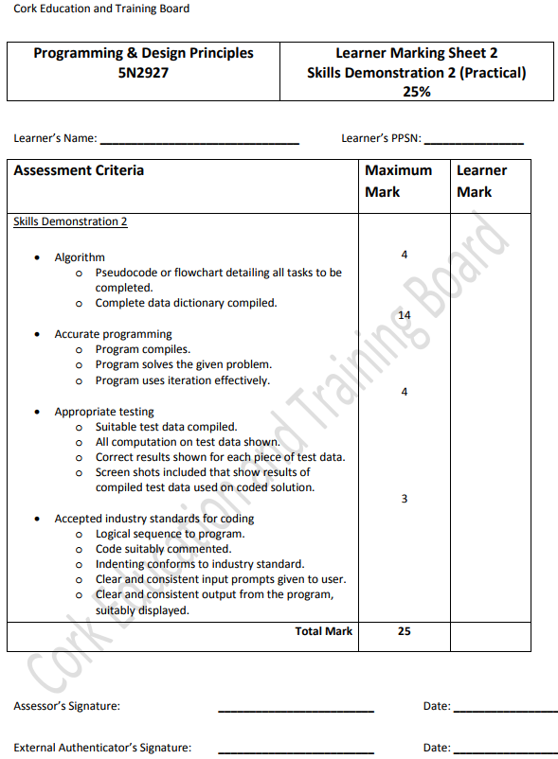

Output only if the person is availing of optional extras

