Letters and ‘ only from Input
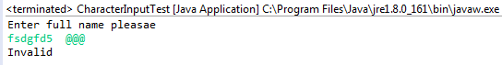

import java.util.*;
import java.io.*;

public class CharacterInputTest {

public static void main(String[] args) {
Scanner in = new Scanner(System.in);

System.out.println("Enter full name pleasae");
String answer=in.nextLine();
if(answer.matches("[a-zA-Z\\'\\- ]+")) {
System.out.println("valid");
}
else {
System.out.println("Invalid");
};
}
}

