Functions in Java

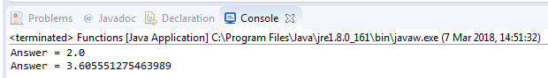

public class Functions {

public static void main(String[] args) {

System.out.println("Answer = "+ calculateSqrt(4));
System.out.println("Answer = "+ calculate(3,2));
}

public static double calculateSqrt(double a) {
return Math.sqrt(a);
}

public static double calculate(double a, double b) {
return Math.sqrt(a*a + b*b);
}
}

