What are factors? Example

- a number or quantity that when multiplied with another produces a given number or expression. In mathematics, a divisor of an integer, also called a factor of, is an integer that may be multiplied by some integer to produce.
- Factors of 12, examples 2 x 6 or 3 x 4

Factorising

- Parts common to a few parts

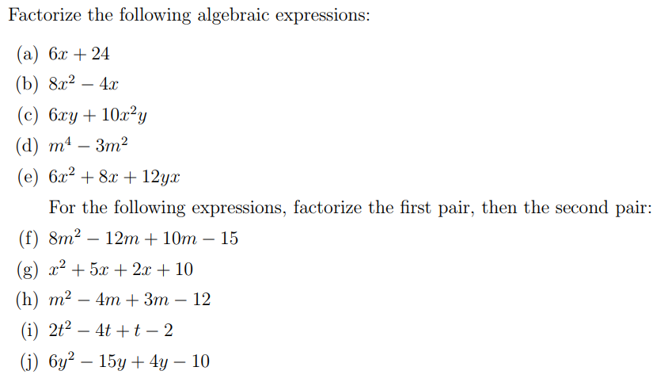

Difference of two squares

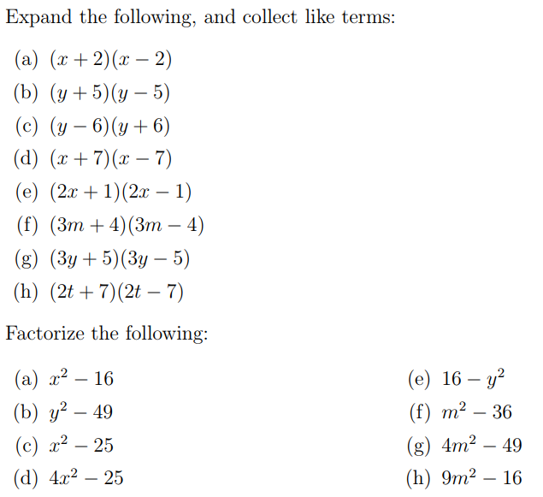

Quadratics

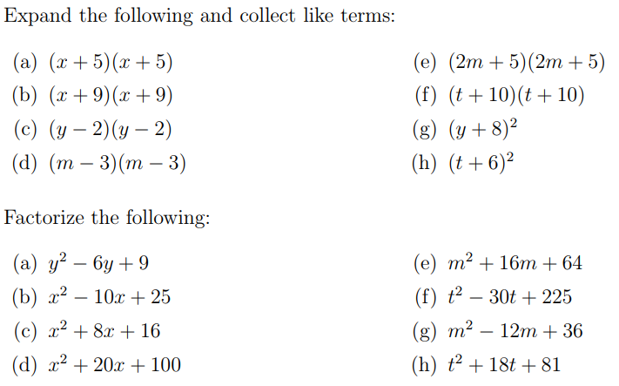

Using the -b formula for solving quadratics

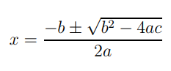

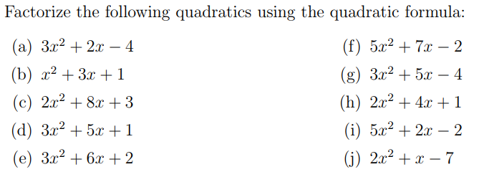

Factorising Examples

- Common parts Example 4x-10 = 2x(2-5)
- Difference of 2 squares
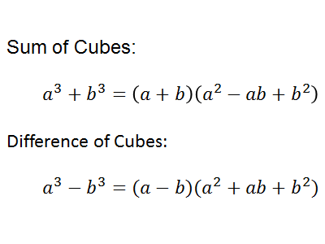
Uses of factorising

