Exercise using your Smartphone

- Check how much memory is available on your mobile, take a screenshot and insert into Word. See example below.
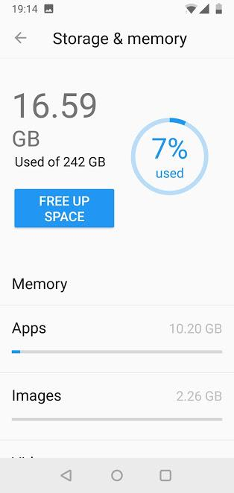

- Turn on the Wifi on your mobile and log onto the CSN Student network. Once connected take a screenshot displaying that you are connected to the college network.

- Download and install the Met Éireann app on your mobile and provide a screenshot showing the app installed.

- Run the app and take a screenshot of the launched app.

