Character Search in a String
Output
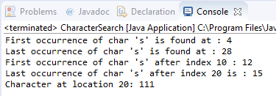
Source Code
package ClassExercises;

public class CharacterSearch {

public static void main(String[] args) {
// This is a string in which a character
// to be searched.
String str = "GeeksforGeeks is a computer science portal";

// Returns index of first occurrence of character.
int firstIndex = str.indexOf('s');
System.out.println("First occurrence of char 's'" +
" is found at : " + firstIndex);

// Returns index of last occurrence specified character.
int lastIndex = str.lastIndexOf('s');
System.out.println("Last occurrence of char 's' is" +
" found at : " + lastIndex);

// Index of the first occurrence of specified char
// after the specified index if found.
int first_in = str.indexOf('s', 10);
System.out.println("First occurrence of char 's'" +
" after index 10 : " + first_in);

int last_in = str.lastIndexOf('s', 20);
System.out.println("Last occurrence of char 's'" +
" after index 20 is : " + last_in);

// gives ASCII value of character at location 20
int char_at = str.charAt(20);
System.out.println("Character at location 20: " +
char_at);

// throws StringIndexOutOfBoundsException
// char_at = str.charAt(50);

}
}

