CSN Gym

Sports Field/Pitches
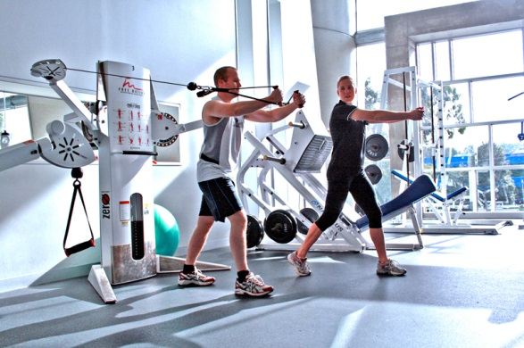
There are several acres of playing pitches on college campus. Three large shower and changing facilities can be accessed from the college Sports hall. The pitches are used for tuition purposes as well as team training and match fixtures in College Competitions. The pitches at CSN are a regular venue for NGBs running coaching courses with ample parking and canteen facilities close by. It is advised that team buses travelling park outside the college on Tramore Rd.

Sports Hall
The College has a large state of the art sports hall. It caters for a variety of indoor sports, particularly indoor soccer, basketball, badminton, indoor hockey, gymnastics and volleyball. It is bright and spacious and has excellent showering and changing facilities.

Performance Gym
The CSN gym is located upstairs in the sports hall and is available to students outside scheduled classes in the gym. There are qualified NCEF instructors to supervise and make out individual training programmes. It has a wide range of sports equipment ranging from a number of CV machines, numerous machine weights, and ample free weights with Olympic bars and squat racks.

For more information see the main Gym page.
Toning / circuits
Students are welcome to participate in various toning and circuit classes in the gym / sports hall
Sports Injury Clinic
ITEC Qualified Massage students run clinics weekly in the Sports Injury Room.

