Real Number Sets
- Natural (N) numbers are the counting numbers {1, 2, 3, ...} (positive integers) or the whole numbers {0, 1, 2, 3, ...} (the non-negative integers). ... Zero does not have a positive or negative value. Zero is however considered a whole number, which in turn makes it an integer, but not necessarily a natural number. ... They have to be positive, whole numbers. Zero is not positive or negative.
- Integers (Z) are the natural numbers and their negatives {... −3, −2, −1, 0, 1, 2, 3, ...}
- Rational (Q) numbers are the ratios of integers, also called fractions, such as 1/2 = 0.5 or 1/3 = 0.333... Rational decimal expansions can end or repeat. (Q is from quotient.)
- Real Algebraic: The real subset of the algebraic numbers: the real roots of polynomials. Real algebraic numbers may be rational or irrational. √2 = 1.41421... is irrational. Irrational decimal expansions neither end nor repeat.
- Real (R) numbers are all the numbers on the continuous number line with no gaps. Every decimal expansion is a real number. Real numbers may be rational or irrational, and algebraic or non-algebraic (transcendental). π = 3.14159... and e = 2.71828... are transcendental. A transcendental number can be defined by an infinite series.
- Imaginary numbers are numbers whose squares are negative. They are the square root of minus one, i = √−1, and all real number multiples of i, such as 2i and i√2.
- Algebraic: The roots of polynomials, such as ax³ + bx² + cx + d = 0, with integer (or rational) coefficients. Algebraic numbers may be real, imaginary, or complex. For example, the roots of x2 − 2 = 0 are ±√2, the roots of x2 + 4 = 0 are ±2i, and the roots of x2 −4x +7 = 0 are 2±i√3.
- Complex numbers, such as 2+3i, have the form z = x + iy, where x and y are real numbers. x is called the real part and y is called the imaginary part. The set of complex numbers includes all the other sets of numbers. The real numbers are complex numbers with an imaginary part of zero.
- Infinity ∞ Continues forever
Real Number Set
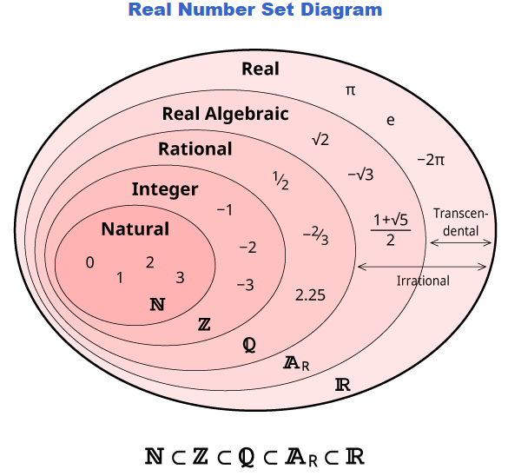
Real Number line
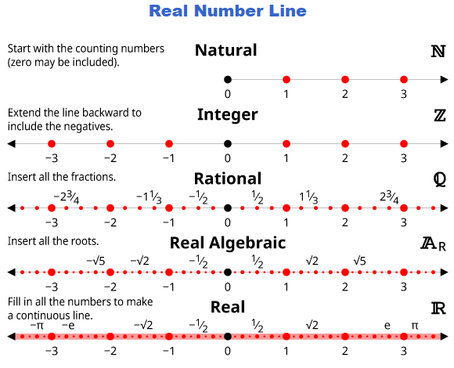

Constant – Coefficient – Variable – Operaor – Exponent

