Variable Scope - Class and Local Variable

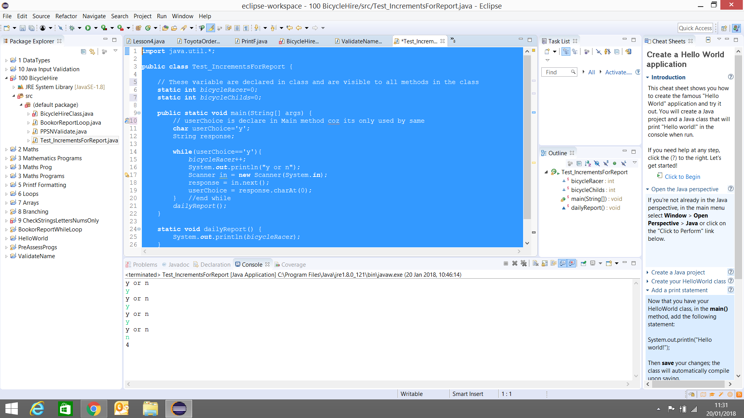

import java.util.*;

public class Test_IncrementsForReport {

// These variable are declared in class and are visible to all methods in the class
static int bicycleRacer=0;
static int bicycleChilds=0;

public static void main(String[] args) {
// userChoice is declare in Main method coz its only used by same
char userChoice='y';
String response;

while(userChoice=='y'){
bicycleRacer++;
System.out.println("y or n");
Scanner in = new Scanner(System.in);
response = in.next();
userChoice = response.charAt(0);
} //end while
dailyReport();
}

static void dailyReport() {
System.out.println(bicycleRacer);
}

}

