Validate Strings
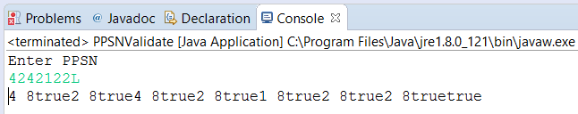

import java.util.*;

public class PPSNValidate {

public static void main(String[] args) {
// PPSN
Scanner in = new Scanner(System.in);
System.out.println("Enter PPSN");
String PPSN = in.next();
boolean ValidPPSN=false;
for (int index = 0; index < PPSN.length()-1;index++) {
char aChar = PPSN.charAt(index);
System.out.print(aChar + " ");
System.out.print(PPSN.length());
if (Character.isDigit(aChar))
{
ValidPPSN=true;
System.out.print(ValidPPSN);
}
else {
ValidPPSN=false;
}
}
char lastChar = PPSN.charAt(7);
if (Character.isLetter(lastChar) && ValidPPSN){
ValidPPSN=true;
}
System.out.print(ValidPPSN);
}
}

