Geometry and Trigonometry

Identify standard imperial and metric units of measure for length, area, volume, and capacity.

Length

Metric |  | Imperial
1 millimetre [mm] |  | 0.03937 in
1 centimetre [cm] | 10 mm | 0.3937 in
1 metre [m] | 100 cm | 1.0936 yd
1 kilometre [km] | 1000 m | 0.6214 mile

Imperial |  | Metric
1 inch [in] |  | 2.54 cm
1 foot [ft] | 12 in | 0.3048 m
1 yard [yd] | 3 ft | 0.9144 m
1 mile | 1760 yd | 1.6093 km
1 int nautical mile | 2025.4 yd | 1.853 km

Area

Metric |  | Imperial
1 sq cm [cm²] | 100 mm² | 0.1550 in²
1 sq m [m²] | 10,000 cm² | 1.1960 yd²
1 hectare [ha] | 10,000 m² | 2.4711 acres
1 sq km [km²] | 100 ha | 0.3861 mile²

Imperial -> |  | Metric
1 sq inch [in²] |  | 6.4516 cm²
1 sq foot [ft²] | 144 in² | 0.0929 m²
1 sq yd [yd²] | 9 ft² | 0.8361 m²
1 acre | 4840 yd² | 4046.9 m²
1 sq mile [mile²] | 640 acres | 2.59 km²

Volume / Capacity

Metric -> |  | Imperial
1 cu cm [cm³] |  | 0.0610 in³
1 cu decimetre [dm³] | 1,000 cm³ | 0.0353 ft³
1 cu metre [m³] | 1,000 dm³ | 1.3080 yd³
1 litre [l] | 1 dm³ | 1.76 pt
1 hectolitre [hl] | 100 l | 21.997 gal

Imperial -> |  | Metric
1 cu inch [in³] |  | 16.387 cm³
1 cu foot [ft³] | 1,728 in³ | 0.0283 m³
1 fluid ounce [fl oz] |  | 28.413 ml
1 pint [pt] | 20 fl oz | 0.5683 l
1 gallon [gal] | 8 pt | 4.5461 l

Mass

Metric -> |  | Imperial
1 milligram [mg] |  | 0.0154 grain
1 gram [g] | 1,000 mg | 0.0353 oz
1 kilogram [kg] | 1,000 g | 2.2046 lb
1 tonne [t] | 1,000 kg | 0.9842 ton

Imperial -> |  | Metric
1 ounce [oz] | 437.5 grain | 28.35 g
1 pound [lb] | 16 oz | 0.4536 kg
1 stone | 14 lb | 6.3503 kg
1 hundredweight [cwt] | 112 lb | 50.802 kg
1 long ton (UK) | 20 cwt | 1.016 t

Convert between SI and Imperial Units.

These units multiplied by this factor will convert to these units
Metres | 100 |  |  | Centimetres
Metres | 3.281 |  |  | Feet
Metres | 39.37 |  |  | Inches
Metres | 0.001 |  |  | Kilometres
Metres | 5.40E-04 |  |  | Miles (nautical)
Metres | 6.21E-04 |  |  | Miles (statute)
Metres | 1000 |  |  | Millimetres
Metres | 1.094 |  |  | Yards
Acre | 0.4047 |  |  | Hectare
Acres | 43560 |  |  | Sq. feet
Acres | 4046.873 |  |  | Sq. metres
Acres |  |  | 0.001562 |  |  | Sq. miles
Acres |  |  | 4840 |  |  | Sq. yards
Miles (nautical) |  |  | 6080.27 |  |  | Feet
Miles (nautical) |  |  | 1.852 |  |  | Kilometres
Miles (nautical) |  |  | 1852 |  |  | Metres
Miles (nautical) |  |  | 1.1516 |  |  | Miles (statute)
Miles (nautical) |  |  | 2027 |  |  | Yards
Miles (statute) |  |  | 1.61E+05 |  |  | Centimetres
Miles (statute) |  |  | 5280 |  |  | Feet
Miles (statute) |  | 6.34E+04 |  |  | Inches
Miles (statute) |  | 1.609 |  |  | Kilometres
Miles (statute) |  | 1609 |  |  | Metres
Miles (statute) |  | 0.8684 |  |  | Miles (nautical)
Miles (statute) |  | 1760 |  |  | Yards
Kilometres |  | 1.00E+05 |  |  | Centimetres
Kilometres |  | 3280.84 |  |  | Feet
Kilometres |  | 3.94E+04 |  |  | Inches
Kilometres |  | 1000 |  |  | Metres
Kilometres |  | 0.6214 |  |  | Miles
Kilometres |  | 1.00E+06 |  |  | Millimetres
Kilometres |  | 1094 |  |  | Yards

Inches |  | 2.54 |  | Centimetres
Inches |  | 0.08333333 |  | Feet
Inches |  | 0.0254 |  | Metres
Inches |  | 0.00001578 |  | Miles
Inches |  | 25.4 |  | Millimetres
Inches |  | 0.027777778 |  | Yards
Square metres | 2.47E-04 |  | Acres
Square metres | 1.00E+04 |  | Sq. cm
Square metres | 10.763915 |  | Sq. feet
Square metres | 1550 |  | Sq. inches
Square metres | 3.86E-07 |  | Sq. miles
Square metres | 1.00E+06 |  | Sq. millimetres
Square metres | 1.196 |  | Sq. yards
Square inches | 6.452 |  | Sq. cm
Square inches | 6.94E-03 |  | Sq. feet
Square inches | 645.2 |  | Sq. millimetres
Square inches | 7.72E-04 |  | Sq. yards
Square kilometres | 247.1 |  | Acres
Square kilometres | 1.00E+10 |  | Sq. cm
Square kilometres | 1.08E+07 |  | Sq. ft
Square kilometres | 1.55E+09 |  | Sq. inches
Square kilometres | 1.00E+06 |  | Sq. metres
Square kilometres | 0.3861 |  | Sq. miles
Square kilometres | 1.20E+06 |  | Sq. yards

Square centimetres | 1.08E-03 | Square feet
Square centimetres | 0.155 | Square inches
Square centimetres | 0.0001 | Square metres
Square centimetres | 3.86E-11 | Sq. miles
Square centimetres | 100 | Sq. millimetres
Square centimetres | 1.20E-04 | Sq. yards
Square feet | 2.30E-05 | Acres
Square feet | 929 | Sq. cm
Square feet | 144 | Sq. inches
Square feet | 0.09290304 | Sq. meters
Square feet | 3.59E-08 | Sq. miles
Square feet | 9.29E+04 | Sq. millimetres
Square feet | 0.1111 | Sq. yards

In general: Imperial and Metric Measurements

Imperial Metric
Length inches, feet, yard, miles millimetre, centimetre, metre, kilometre
Area inches², foot² mm², cm²
Volume inches³ foot³, mm³, cm³
Capacity pint, gallon litre

Questions
- If Victor Costello weighs 18 ½ stone, how many kilograms (kg) does he weigh?
- Next to the Elephant, the White Rhino is the largest land mammal and can weigh up to 3.6 metric tons. What weight is that in stones (1 stone = 14 lbs.)?
- The local swimming pool contains 1,000 gallons of water. How many litres is that?
- A tank is 5ft. * 5ft. by 3 ft. deep. What is the volume of the tank in m³?
- It’s 101 km from Cork to Limerick. What is that in miles?
- If it’s 22 miles from Tralee to Killarney, how many kilometres is that?
- A marathon is approximately 26.2 miles long. Convert that to kilometres.
- Ronan O’Gara is 6ft tall exactly. What is his height in metres?
- Carrauntoohill is 3,414 ft in height. Convert that to metres.
- The Croke park pitch is 100 by 150 yards. What size is that in metres²?
- How many acres in a 15.3 ha. farm?
- How many metres squared is there 6 acres?

Measure the size of any angle, in degrees, using a protractor.
Measure the following angles using a protractor.

B
A C

A

B

A
B

Convert between Degrees and Radians
In everyday life it is usual to measure angles in degrees (abbreviated ° ). 1° is divided into 60 minutes (abbreviated ' ), and each minute is divided into 60 seconds (abbreviated " ). If a circle is drawn with its centre at the vertex of an angle of 1° then the arms of the angle cut off an arc whose length is 1/360 of the circumference of the circle (see diagram).
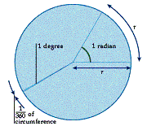

Although degrees are more commonly used, the SI unit for measuring angles is the radian (rad.). If a circle is drawn with its centre at the vertex of an angle of 1 rad. then the arc of the circle cut off by the arms of the angle has a length equal to the radius of the circle (see diagram above). The length of the circumference of a circle of radius r is 2πr. Therefore, 2π rad. = 360°. So 1 rad. = 180/π° ≈ 57.29578° (to 5 decimal places) and 1° = π/180 rad. ≈ 0.01745 rad. (to 5 decimal places).

So, for example, an angle of 90° is the same as an angle of π/2 rad, and an angle of 180° is the same as an angle of π rad.

Definition
One radian is the measure of the angle at the centre of a circle subtended by an arc equal in length to the radius.
r
1 radian

r

Note 1: We have the following formula connecting r, the radius length of a circle, s, the length of an arc, and A, the angle at the centre (measured in radians).
A
s

Formula 1

A = s/r
r

For example, in the diagram opposite
A
0.75 cm
A = ^{0.75}/_{1.75} radians
1.75 cm
= ³/₇ radians

Note 2: Formula 1 may be used to derive the link between the two different ways of measuring angles, in degrees and in radians.
2πr
Consider a circle of radius r whose circumference is 2πr. In degrees, the angle at the centre of the circle is 360º. However, by Formula 1, this angle may also be written
r

radians = 2π radians
2πr
r

Definition
360º = 2π radians
180º = π radians
Thus:

To express any number of degrees in radians, or vice versa, write down the definition and multiply or divide both sides as appropriate. Some of the more common angles are given below.

Degrees | 0º | 30º | 45º | 60º | 90º | 180º | 270º | 360º
Radians | 0 | ^{π}/₆ | ^{π}/₄ | ^{π}/₃ | ^{π}/₂ | π | ^{3π}/₂ | 2π

Questions
1. Find the length of the arc of a circle of radius 3 cm subtending an angle of;
- 2 radians, (ii) ^{π}/₂ radians, (iii) 1.7 radians.
2. Find the radius of a circle if an angle of 1.3 radians is subtended by an arc of length
- 2 cm, (ii) 5 cm, (iii) 3.9 cm.
3. Find the measure of the angle at the centre of a circle of radius 3 cm subtended by an arc of length
- 0.6 cm, (ii) 0.25 cm, (iii) 1.35 cm.
4. Express in radians: (i) 72º, (ii) 215º, (iii) 240º, (iv) 288º.
5. Express in degrees the following numbers of radians:
(i) ^{3π}/₅ (ii) ^{11π}/₉ (iii) ^{14π}/₃ (iv) ^{7π}/₁₂

Use Standard results for angles, triangles, polygons, circles, and common solids.

Describe Folding and Rotational Symmetry in Common Structures

Folding Symmetry
Using a square, traced and cut from construction paper, how many times can you fold the shape to divide it so that it has symmetrical sides—this is its line of symmetry? Fold the shape to show where the line of symmetry is. Is there another? Some shapes may have more than one line of symmetry. Keep folding until you have found the four lines of symmetry for a square (horizontally, vertically, and across both diagonals).

Next, look around the room for shapes and objects that are symmetrical. Identify the line(s) of symmetry in each object you choose.

Start a chart on the board like this:
Shape | Number of sides | Number of lines of folding symmetry | Order of rotational symmetry

Triangle
Square | 4 | 4 | 4
Pentagon
Hexagon
Heptagon
Octagon

Determine the number of sides and lines of symmetry in the table above. Discuss the pattern and relationship of the number of sides to the lines of symmetry.

Examples of rotational symmetry in common structures are as follows;

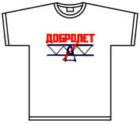

Etc.
Rotational Symmetry Activity
Trace the outline of an equilateral triangle onto a piece of white paper. Rotate the shape until it matches its traced outline again. How many times will the triangle match the outline as you spin it completely around once? (Three times) You can then say that the triangle has three orders of rotational symmetry.
a
c
b
Note: If a shape “matches” itself only once in a full rotation, it does not have rotational symmetry.
a
c
b
a
c
b

An object has rotational symmetry if there is a centre point, around which the object is turned a certain number of degrees, and the object still looks the same (matches itself) a number of times while being rotated. Rotate a given shape to find how many orders of rotational symmetry it has. Add that number to the chart above.

The number of repeated elements in rotational symmetry can vary significantly, although three is the minimum number of repetitions. Natural examples of rotational symmetry can be found in starfish, flowers, and snowflakes. Many cultural objects exhibit rotational symmetry including tile work, basket patterns, and kaleidoscopes (see below).
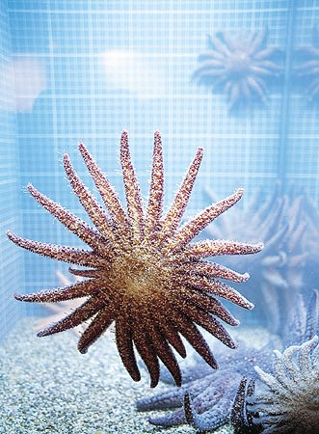
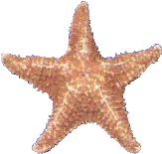
Starfish

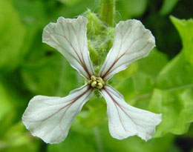
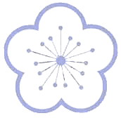
Flowers
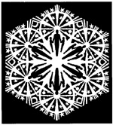

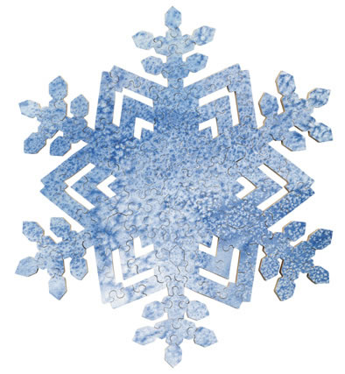

Snowflakes

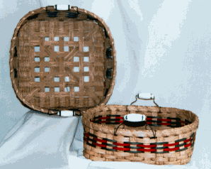
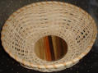

Baskets

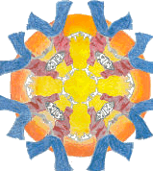


Kaleidoscopes

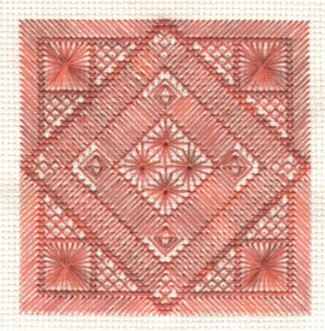

Carpet pattern

Making Shapes with Rotational Symmetry
Determine how many orders of rotational symmetry each design has, and enter the findings into the chart below:

Number of folds | Order of rotational symmetry
One
Two
Three, etc.

Mirror or reflection symmetry divides a figure or design into halves that are mirror images of each other. The axis can be located either vertically or horizontally. Mirror symmetry is found in both natural and man-made objects. Butterflies are good examples of natural mirror symmetry. Human faces have symmetry! In fact, most animals and plants exhibit some form of symmetry (bi-lateral) in their body shape and their markings.
Different (equilateral ) shapes

Square Triangle

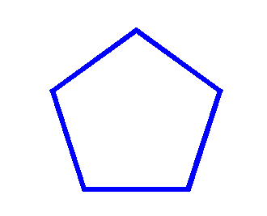

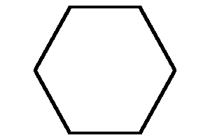

Pentagon Hexagon

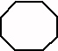

Heptagon

Describe Pattern
Pattern with regard to objects is the repetition of a unique shape

Pattern with regard to recurring numbers occurs when a number or several numbers are recurring to infinity
.

0.03 = 0.0333333333333333…
..

0.21 = 0.2121212121212121…
..

2.517 = 2.51717171717171717…

Trigonometry is the study of how the sides and angles of a triangle are related to each other.
Trigonometry

Use Pythagoras’ Theorem
Pythagoras’ Theorem states that
In a right-angled triangle, the area of the square on the hypotenuse is equal to the sum of the squares on the other two sides.

a
The given triangle, abc is right-angled as ac ² = ab ² + bc ² i.e. 10² = 6² + 8².
100 = 36 + 64
6 10

b c
8

The proof is based on a right-angled triangle abc, as shown below, where
Proving Pythagoras’ Theorem
bac = 90º and ad bc.

a

β

c
β
b
d

The equal angles marked above show that:
- The triangles abc and adc are similar (they share an angle and a side)
- The triangles abc and abd are similar (they share an angle and a side)
- The triangles abd and adc are similar (they share a side and each contains an angle of 90º

Given: abc in which bac = 90º.

To Prove bc ² = ab ² + ac ²

Construction: Draw ad bc.

Proof: The triangles abc and abd are similar.

bc ab
=
=>
ab bd
=>
ab ² = bc * bd . . . . (A)

The triangles abc and adc are also similar.

ac bc
=>
=
dc ac
=>
ac ² = bc * dc . . . . (B)

Adding A and B we get:

ab ² + ac ² = bc * bd + bc * dc

= bc { bd + dc }
= bc * bc
= bc ²
=>
ab ² + ac ² = bc ²
i.e. bc ² = ab ² + ac ².
Questions
Find the length of the side marked x in the following triangles.

(i) (ii) (iii)
√54
6
x
x
10
x

8 6 x

Find the length of the side marked x in each of the following triangles:

(i) (ii) (iii)

7
x
3
5
8
x
x

3
2
3
4

Find the values of x and y in the given
diagram.

13
√29
x

y
2

The Trigonometrical ratios sin, cos and tan and Pythagoras’ Theorem only work for Right-Angled Triangles

Triangle Worksheet
Label the sides of each triangle as ‘opp’, ‘adj’, or ‘hyp’ relative to the marked angle.
‘opp’ = opposite, ‘adj’ = adjacent, ‘hyp’ = hypotenuse
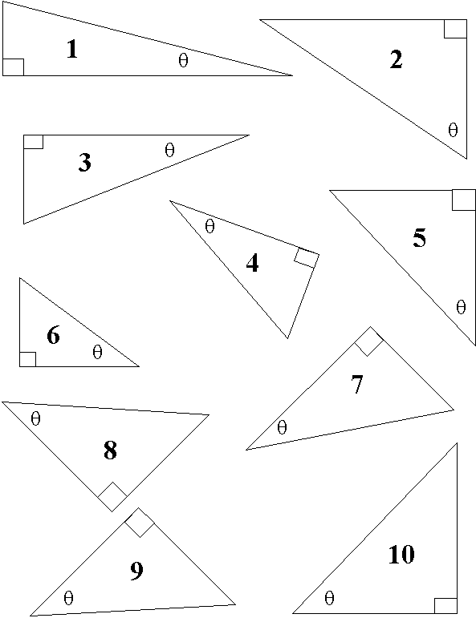
Define sine, cosine and tangent as ratios of sides of a right triangle

opposite side
sin A =
hypotenuse
hypotenuse

opposite
side (to A)
adjacent side
cos A =
hypotenuse

opposite side
tan A =
A
adjacent side
Adjacent side (to A)

Memory aid: Oh Hell, Another Hour, Of Algebra, sin, cos and tan.

The angles 30˚ and 60˚.
In the equilateral triangle abc below, each side is 2 units in length. The perpendicular from the vertex a to the base gives a triangle of 90˚, 60˚ and 30˚.
a

sin 60˚ = ^{√3}/₂ sin 30˚ = ½
30˚
2
cos 60˚ = ½ cos 30˚ = ^{√3}/₂
√3

tan 60˚ = ^{√3}/₁ tan 30˚ = ¹/_{√3}
60˚

1
b
c

The 45˚ angle
The triangle below is isosceles where the equal sides are each 1 unit in length. The hypotenuse is √2 units in length.

√2
sin 45˚ = ¹/_{√2}

cos 45˚ = ¹/_{√2}

tan 45˚ = 1
1

45˚
1

Given the sides of a Triangle, Calculate the Angles.
Given a value of sin Ө, cos Ө or tan Ө, we can find the value of the angle Ө using the sin⁻¹, cos⁻¹ or tan⁻¹ keys, respectively. On most calculators, sin⁻¹, cos⁻¹ and tan⁻¹ is obtained by first pressing INV or 2nd F and then pressing sin, cos or tan, respectively.

Example
Find the value of Ө, to the nearest minute, given that:
(i) sin Ө = 0.5 (ii) cos Ө = 0.3896

(i) sin Ө = 0.5, therefore [Press: 0.5 INV sin]
Ө = 30º

(ii) cos Ө = 0.3896, therefore [Press: 0.3896 INV cos]
Ө = 67.07038747

Converting from Decimals to Minutes
To get the minutes we multiply the decimal part by 60.
So cos Ө above = 0.07038747º * 60 = 4.223248446’ = 4’ (nearest minute)
Therefore Ө = 67º 4’ [to the nearest minute]

Solve right triangles using sine, cosine, tangent

Questions
Find the measure (to the nearest degree) of the angle marked with a capital letter in the triangles below:

B
12
4.5

5
A
C

8 7 3.4
b

In the given diagram acd is a straight line and bd ad. If bd = 6 cm, ab = 11 cm, find
11 cm
6 cm
- bad
- ad , correct to 1 decimal place.
c
a
d

A tree’s shadow is exactly 30 metres long. If that tree is growing upright, and the sun is at 30˚ elevation in the sky, what is the tree’s height?

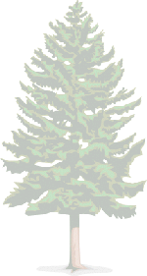
30 m
30˚

In the given diagram cb = k
Express ab in terms of k.
60˚
c

60˚
k

60˚
30˚
b
a

Find ab in the given isosceles triangle abc, if bc = √3 and abc = 30˚
a

c
b
30˚

√3
Solve Practical Problems (angles of elevation / depression, bearings, simple surveying problems).
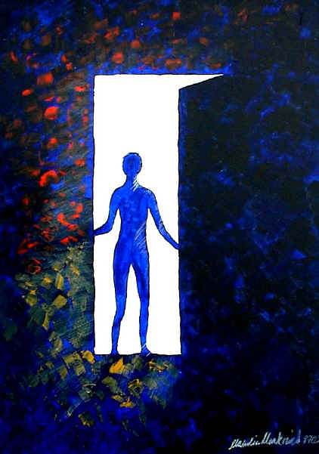

Line of observation
B
Angle of
depression

Line of observation
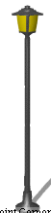

Angle of
elevation
A

The angle marked A is called an angle of elevation.
The angle marked B is called an angle of depression.

Example
Surveyors use the tangent (tan) function a lot. For example, they can use trigonometry to figure out the distance across rivers.
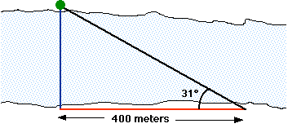
We first set up a survey post directly across the river from some landmark (like a tree). Then we head downstream a distance that we can measure; in this case, 400 meters. That's the red horizontal line in the drawing. Now we take a sighting on the tree from downstream. That's the black line in the drawing. The surveying instruments will tell us what our sighting angle is. In this case, it's 31 degrees. We know from the previous page that the tangent of 31 degrees is equal to the length of the blue line divided by the length of the red line (400 meters). So, if we multiply the tangent of 31 degrees by 400 meters, we'll get the distance across the river. The tangent of 31 degrees is about 0.60. That means that the distance across the river is 0.6 times 400 meters, or 240 meters.

Questions
A rod of length 7√2 cm is inclined to the horizontal at an angle of ^{π}/₄ radians. A shadow is cast immediately below it from a lamp directly overhead. What is the length of the shadow? What is the new length of the shadow if the rod’s inclination is changed to ^{π}/₃ to the vertical?

A building casts a horizontal shadow 8√3m long. If a line were to be drawn from the end of the shadow to the top of the building it would be inclined to the horizontal at 60˚. What is the height of the building?

A prop in the form of an isosceles triangle constructed out of timber is placed against a vertical wall. If the length of the side along the horizontal ground is 3.4 m, what is the length of the hypotenuse to 2 decimal places?

45˚

45˚
3.4 m

A bicycle frame is in the form of an isosceles triangle with the horizontal crossbar forming the hypotenuse. If the crossbar is 53 cm long, find the length of each of the other two sides to the nearest mm.

N

Simple Bearing Problems
A
Compass Directions
The direction to a point is stated as a number of degrees East or West of North and South.
B
50º
70º
W
E

60º
45º

D

A is N 50º E
C
B is N 70º W
S
C is S 45º W
D is S 60º E

Note: N 50º E means 50º East of North.
Questions
An observer in a lighthouse 140m high observes the angle of depression of a boat to be 40º 25’. If the foot of the lighthouse is at sea level, how far is the boat form the base of the lighthouse?

Two ships leave a harbour at the same time. One sails in a direction S 73º E and the other in a direction S 17º W at 5 km/h and 5¼ km/h, respectively. How far are the ships apart after 4 hours’ sailing?
p

On leaving a port p, a fishing boat sails in the direction South 30º East for 2 hours at 10 km/h, as shown. What distance has the boat then sailed? The boat next sails in the direction North 60º East, at 10 km/h, until it is due East of the port p. Draw a diagram of the boat’ journey. Calculate how far the boat is from the port.
30º

Define sine, cosine and tangent functions as related to the unit circle

The Unit Circle
p(x, y)
The circle on the right has centre at (0,0) and radius 1 unit in length. It is generally referred to as the unit circle.
Ө
0
1
c
x
y

Let p(x, y) be any point on the circle, as shown above.
p(cos Ө , sin Ө)
^{X}/₁ = cos Ө => x = cos Ө

^{y}/₁ = sin Ө => y = sin Ө
Ө

=> the co-ordinates of p are (cos Ө , sin Ө)

The co-ordinates of any point on the unit circle are (cos Ө, sin Ө)
Remember
Sin, Cos and Tan of 0˚, 90˚, 180˚, 270˚ and 360˚.
The unit circle is particularly useful when finding the sine or cosine of the angles 0˚, 90˚, 180˚, 270˚ and 360˚. The diagram below shows the values of sine and cosine of the angles mentioned above.
(cos 90˚, sin 90˚)
(0,1)

1

1 1
(cos 0˚, sin 0˚)
(1,0)
(cos 180˚, sin 180˚)
(-1,0)

1
(cos 270˚, sin 270˚)
(0,-1)

From the unit circle above:

cos 0˚ = 1 cos 90˚ = 0 cos 180˚ = -1 cos 270˚ = 0
sin 0˚ = 0 sin 90˚ = 1 sin 180˚ = 0 sin 270˚ = -1

Note: sine and cosine of 0º are the same as sine and cosine 360˚.

Since tan Ө = ^{sin Ө}/_{cos Ө}, we can also use the unit circle to find the value of the tangent of the angles 0˚, 90˚, 180˚, 270˚ or 360˚.

Thus
- tan 0˚ = ⁰/₁ = 0
- tan 90˚ = ¹/₀ …(not a real number)
- tan 180˚ = ⁰/₋₁ = 0
- tan 270˚ = ⁻¹/₀ …(not a real number)

The Four Quadrants
90˚
The x-axis and y-axis divide a full rotation of 360˚ into 4 quadrants as shown on the right.
Second Quadrant
First Quadrant

360˚
180˚

Fourth
Quadrant
Third
Quadrant

270˚
The unit circle below shows an angle of Ө in each of the four quadrants. The signs shown in each triangle determine whether a ratio is positive or negative. The signs of the sine, cosine and tangent of an angle in each quadrant are shown.
90˚

sin +
cos -
tan -
sin +
cos +
tan +

+ +
360˚
0˚
Ө
Ө
_
+
180˚
Ө
Ө

_ _
sin -
cos -
tan +
sin -
cos +
tan -

270˚

Remember CAST!
The diagram shows the positive ratios in the four quadrants.
- In the 1st quadrant, all (A) positive.
- In the 2nd quadrant, sin (S) only positive.
- In the 3rd quadrant, tan (T) only positive.
- In the 4th quadrant, cos (C) only positive.

S+
A+

C+
T+

Finding the Ratio of an Angle between 90˚ and 360˚
A calculator will give you the sine, cosine and tangent of any angle including the negative sign, if it exists. If Mathematics Tables are used these steps should be followed:
- Determine in which quadrant the angle lies.
- Hence, state if the sign of the ratio is positive or negative.
- Determine the angle (< 90˚) between the rotated line and the x-axis.
- Read the required ratio of the angle from your tables and insert the sign from (ii) above.

Negative Angles
When a line is rotated in a clockwise direction it generates a negative angle. Some negative angles are shown below:

60˚
150˚

-60˚

-150˚

Example 1
Find cos 168˚
The cos ratio is negative in the 2nd quadrant.
168˚
=> cos 168˚ = - cos (180˚ - 168˚)
12˚
= - cos 12˚
= - 0.9781

Example 2
If tan A = ¾ , find two values for sin A, where 0˚ ≤ A ≤ 360˚, giving your answers as fractions.
90˚

tan A = ¾ => sin A = ³/₅
5
3
tan +

A
180˚
0˚
4
tan +

If tan A = ¾ , then A may be an angle
270˚
- between 0˚ and 90˚, or
- between 180˚ and 270˚, since the tan ratio is positive in both of these quadrants.

=> sin A = ³/₅ (1st quadrant) or – ³/₅ (3rd quadrant).

Questions
Use a calculator to write down the values of these ratios:
(i) sin 134˚ (ii) cos 210˚ (iii) tan 318˚ (iv) cos 159˚
(v) tan 311˚ (vi) sin 197˚ (vii) cos 330˚ (viii) tan 254˚

If tan 120 = -tan 60, copy and complete the following in the same way:
(i) sin 140˚ = (ii) tan 104˚ = (iii) cos 210˚ =
(iv) tan 290˚ = (v) sin 254˚ = (vi) cos 153˚ =

If sin A = 0.2483, find 2 values of A if 0˚ ≤ A ≤ 360˚

If tan B = -1.2474, find 2 values of B if 0˚ ≤ B ≤ 360˚

Find A if sin A = -⁴/₅ and cos A = -³/₅

If tan A = ½ and 180˚ < A < 270˚, which of the following is equal to sin A?
(i) ²/_{√ 5} (ii) -¹/_{√ 5} (iii) -²/_{√ 5} (iv) ¹/_{√ 5}

Trigonometric Graphs
Graph and Analyse the Functions y = sin x, y = cos x, y = tan x

Consider the function f: → ; x → sin x

The field of all rational and irrational numbers is called the real numbers, or simply the "reals," and denoted .

The set of reals is denoted by .
(in this case π and √3 are irrational)

A function is a mathematical relation such that each element of one set is associated with at least one element of another set.

By preparing a table of values, we can plot the graph of y = f(x) = sin x

for -2π ≤ x ≤ 2π

x | -2π | -^{3π}/₂ | -π | -^{π}/₂ | 0 | ^{π}/₂ | π | ^{3π}/₂ | 2π
y = sin x | 0 | 1 | 0 | -1 | 0 | 1 | 0 | -1 | 0

Thus, the following set of points belongs to the curve y = sin x:

{(-2π, 0), (-^{3π}/₂, 1), (-π, 0), (-^{π}/₂, -1), (0, 0), (^{π}/₂, 1), (π, 0), (^{3π}/₂, -1), (2π, 0)}

y = sin x
(see also Google: y = sin x)

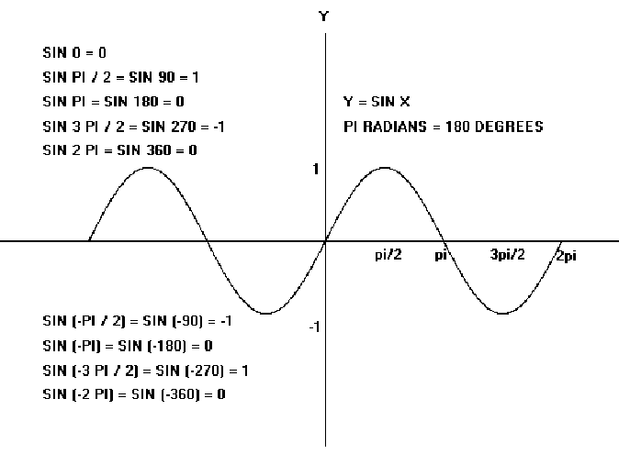
y = sin x

We must notice certain features of the graph.
- The graph is smooth, i.e. there are no sharp points. It is rounded at the top and at the bottom. This could easily be verified by taking many more values of x between those already taken.
- The range of the function, i.e. the interval from the lowest y-value to the greatest y-value is [-1, 1]. Thus

-1 ≤ sin x ≤ 1, for all x

- The graph follows a regular pattern, so we could easily have extended it in either direction by continuing this pattern.
2π

In fact the graph maybe considered
to be a row of the ‘building blocks’ shown on the right, continued to infinity in each direction.

A graph, which has this property, is said to be periodic, and the period is the horizontal length of the building block. It is clear from the graph that the period of
y = sin x is 2π, or 360˚.

Note 1: The graph of f: R → R; x → cos x, i.e y = cos x can be constructed in the same way and is shown below.

x | -2π | -^{3π}/₂ | -π | -^{π}/₂ | 0 | ^{π}/₂ | π | ^{3π}/₂ | 2π
y = cos x | 1 | 0 | -1 | 0 | 1 | 0 | -1 | 0 | 1
Graph of:
y = cos x

Note 2: The shape of the cosine graph is the same as that of the sine graph. Indeed, the cosine graph may be considered as the sine graph simply shifted ^{π}/₂ to the left. Thus, the cosine graph has a range [-1, 1] and period 2π, or 360˚.

Note 3: The graph of the function f: x → tan x is unlike the graph of either a sine or cosine function. On constructing a table of values, we obtain the following graph.

x | -2π | -^{3π}/₂ | -π | -^{π}/₂ | 0 | ^{π}/₂ | π | ^{3π}/₂ | 2π
y = tan x | 0 | ∞ | 0 | ∞ | 0 | ∞ | 0 | ∞ | 0

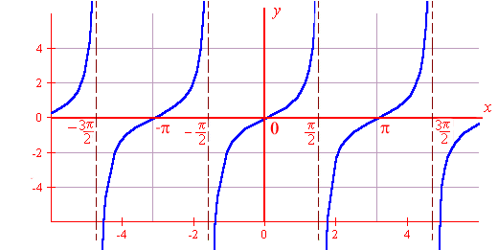
y = tan x

From the graph above, note that:
- The function is not defined for x = ± ^{π}/_{2,} ± ^{3π}/₂, ……., where it tends to infinity.
- The range of the function is , i.e. - ∞ < tan x < ∞, for all x ε .
- The function is periodic, and its period is π, or 180˚.

Derive the Period, amplitude and Phase of Trigonometric Functions
Sine and cosine functions have the form of a periodic wave:

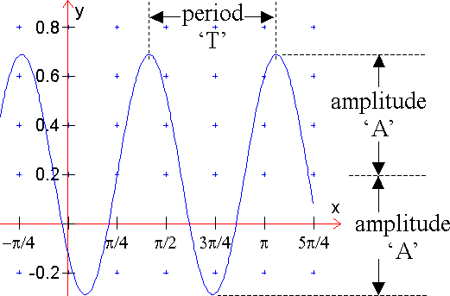
Range
  - The period, T, is the distance between any two repeating points on the function.
  - The amplitude, A, is the distance from the midpoint to the highest or lowest point of the function.
  - Phase shift is the amount of horizontal displacement of the function from its original position.

A function of the form f(x) = a + b sin (cx + ε)

is called a sine function. The graph of a sine function is similar to that of y = sin x, but its period, range and location may be different. In the same way, the graph of the cosine function
f(x) = a + b cos (cx + ε)

is similar to that of y = cos x.

The sine function f(x) = a + b sin (cx + ε) and the cosine function
f(x) = a + b cos (cx + ε) have

- range = [a – b, a + b] if b > 0, or [a + b, a – b] if b < 0
- period = 2π or 360˚
c c
Example 1
Find the range and the period of f(x) = 2 – 3 sin (3x + ^{π}/₂)

Solution
- Range = [2 – 3, 2 + 3] = [-1, 5]
- Period = ^{2π}/₃ = ^{360˚}/₃ = 120˚

Note 5: In practice, one very efficient approach to sketching the graph of a sine function or cosine function is to:

- Write down the period and the range.
- Construct a small table of values, with intervals of one quarter of the period, for one period only. Take as the starting value that value of the variable that makes the angle equal to zero.
- Extend the graph to the required domain.

Example 2
Sketch a graph of the function

f: x → 1 – 2 sin (3x + ^{π}/₂), for –π ≤ x ≤ π

Solution
Period = ^{2π}/₃. Quarter of period = ^{2π}/₃ * ¼ = ^{π}/₆.

Range = [1 – 2, 1 + 2] = [-1, 3]

Put angle = 0. => 3x + ^{π}/₂ = 0 => x = - ^{π}/₆

X | - ^{π}/₆ | 0 | ^{π}/₆ | ^{π}/₃ | ^{π}/₂
3x + ^{π}/₂ | 0 | ^{π}/₂ | π | ^{3π}/₂ | 2π
sin (3x + ^{π}/₂) | 0 | 1 | 0 | -1 | 0
- 2 sin (3x + ^{π}/₂) | 0 | -2 | 0 | 2 | 0
y = 1 – 2 sin (3x + ^{π}/₂) | 1 | -1 | 1 | 3 | 1

Plot these points and extend to – π ≤ x ≤ π
f: x → 1 – 2 sin (3x + ^{π}/₂), for –π ≤ x ≤ π

We model cyclical behaviour using the sine and cosine functions. An easy way to describe these functions is as follows. Imagine a bicycle wheel whose radius is one unit, with a marker attached to the rim of the rear wheel, as shown in the following figure.
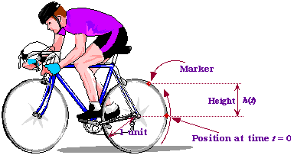

As the wheel rotates, the height h(t) of the marker above the centre of the wheel, fluctuates between 1 and +1.The faster the wheel rotates, the faster the oscillation. Let us now choose our units of measurement so that the wheel has a radius of one unit. Then the circumference of the wheel (the distance all around) is known to be 2, where = 3.14159265.... When the outer edge of the wheel has travelled this distance, it has gone through exactly one revolution, and so it is back where it started. Thus, if at time t = 0 the marker started off at position h(0) = 0, then it is back to zero after one revolution. If the cyclist happens to be moving at a speed of one unit per second, it will take the bicycle wheel 2 seconds to make one complete revolution, and so the wheel is back where it started after that time.

The function h(t) we get in the above way is called the sine function, denoted by sin(t). Here is its graph.
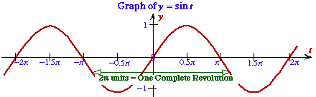

Sine Function

Bicycle Wheel Definition
If a wheel of radius 1 unit rotates at a speed of 1 unit of length per second, and is in the position shown in the figure at time t = 0, then its height after t seconds is given by h(t) = sin(t).

Geometric Definition
The sine of a real number t is given by the y-coordinate (height) of the point P in the following diagram, in which t is the distance of the arc shown.
sin(t) = y-coordinate of the point P.
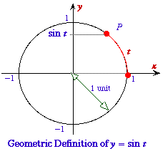

Introduction to Microsoft Excel (data entry, charts of various functions)

Example 1
Function f(x)=x²-3x+5 in the domain –3 to 4.

x | -3 | -2 | -1 | 0 | 1 | 2 | 3 | 4
x² | 9 | 4 | 1 | 0 | 1 | 4 | 9 | 16
-3x | 9 | 6 | 3 | 0 | -3 | -6 | -9 | -12
+5 | +5 | +5 | +5 | +5 | +5 | +5 | +5 | +5
f(x) | 23 | 15 | 9 | 5 | 3 | 3 | 5 | 9

Example 2

f(x)=sin x
x | 0 | 45 | 90 | 135 | 180 | 225 | 270 | 315 | 360
Sin x | 0 | .707 | 1 | .707 | 0 | -.707 | -1 | -.707 | 0

Example 3

f(x)=e^{x}
X | -3.0 | -2.5 | -2.0 | -1.5 | -1.0 | -0.5 | 0 | 0.5 | 1 | 1.5 | 2.0 | 2.5 | 3.0
e^{x} | 0.05 | 0.08 | 0.14 | 0.22 | 0.37 | 0.61 | 1 | 1.65 | 2.72 | 4.48 | 7.39 | 12.18 | 20.09
e^{-x} | 20.09 | 12.18 | 7.39 | 4.48 | 2.72 | 1.65 | 1 | 0.61 | 0.37 | 0.22 | 0.14 | 0.08 | 0.05

Questions
Find the period and range of each of the following functions:
- f(x) = 3 + 2 sin 5x
- f(x) = 3 – 2 sin (^{π}/₃ – x)
- f(x) = -1 + sin 3x
- f(x) = 4 cos 2x
- f(x) = 3 – 4 sin 2x

Sketch the graph of each of the following functions in the stated domain.
- y = 5 + sin x, –2π ≤ x ≤ 2π
- y = 2 sin ( x + ^{π}/₂), –2π ≤ x ≤ 2π
- y = 1 – 3 sin (2x - ^{π}/₃), –2π ≤ x ≤ 2π
- y = 3 – 2 sin (¹/₂x - ^{π}/₂), –4π ≤ x ≤ 4π
- y = 2 cos (2x + ^{π}/₂), -π ≤ x ≤ π

