Toyota Ireland – Ordering System

Toyota Dealerships purchase vehicles by ordering from Toyota Ireland and avail of the following discounts:
Model | Unit Price € | 5% Discount (applies to orders in excess of the following)
Corolla | 27000 | 10
Avensis | 32500 | 8
Rav | 38750 | 6

- A valid order can only consist of a maximum of 40 vehicles. You are required to use a Boolean data type named ValidOrder when processing same.
- VAT is charged at 21% on the total cost.
- A flat rate processing fee of €100 is charged per order (this is exempt from VAT)
The person ordering the vehicles has to supply contact details. This includes their name and mobile phone number.

Design, code and test a Java program that will read in the required details and will output:
- The name of the manager making the order.
- The mobile number of the person making the order.
- The quantity of each of the 3 vehicle models ordered.
- Whether it is a valid order or not.
- The total cost of all vehicles – less discount
- VAT at 21%
- The flat processing fee
- The total cost
A data dictionary and flow chart must be provided including commented source code and screenshots of all test data used. You are required to use test data to test every possible outcome or scenario. You may use Excel to calculate the correct values for test data.
Source code should be indented as appropriate and commented also. Suitable identifier and variable names must be used in line with commonly used standards as discussed in class.

Data Dictionary
Identifier/Variables | Data Type | Description
Corolla | int | Quantity of Corolla vehicles
Avensis | int | Quantity of Avensis vehicles
Rav | int | Quantity of Rav vehicles
Name | String | Name of manager
Mobile | String | Mobile number
CorollaCost | double | Cost of Corolla vehicles
AvensisCost | double | Cost of Avensis vehicles
RavCost | double | Cost of Rav vehicles
VAT | double | VAT of 21% of vehicles cost
ProcessingFee | double | Flat fee of €100
TotalCost | double | Total cost of order
Flow Chart
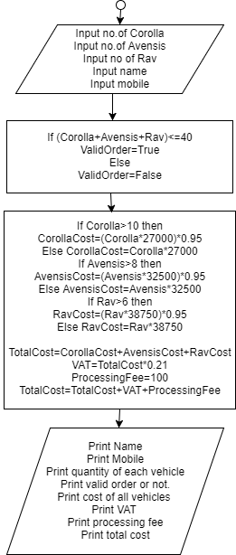
Test Data
Corolla | CorollaCost | Avensis | AvensisCost | Rav | RavCost | Total | VAT | Fee | Cost
4 | 108000 | 6 | 195000 | 7 | 257687.5 | 560687.5 | 117744.375 | 100 | 678531.875
12 | 307800 | 9 | 277875 | 7 | 257687.5 | 843362.5 | 177106.125 | 100 | 1020568.625
10 | 270000 | 3 | 97500 | 8 | 294500 | 662000 | 139020 | 100 | 801120
46 | 1179900 | 43 | 1327625 | 33 | 1214812.5 | 3722337.5 | 781690.875 | 100 | 4504128.375
1 | 27000 | 9 | 277875 | 20 | 736250 | 1041125 | 218636.25 | 100 | 1259861.25

Source Code
import java.util.Scanner;

public class ToyotaOrders {

public static void main(String[] args) {
// Ray O'Connor Toyota Dealerships Order Prog

Scanner in = new Scanner(System.in);
System.out.print("Input no. of Corolla: ");
int Corolla = in.nextInt();
System.out.print("Input no. of Avensis: ");
int Avensis = in.nextInt();
System.out.print("Input no. of Rav: ");
int Rav = in.nextInt();
System.out.print("Input name: ");
String name = in.next();
System.out.print("Input mobile: ");
String mobile = in.next();

boolean ValidOrder;
if ((Corolla + Avensis + Rav)<=40) {
ValidOrder = true;
}
else
{
ValidOrder=false;
}
double CorollaCost, AvensisCost, RavCost;
if (Corolla>10) {
CorollaCost=(Corolla*27000)*(0.95);
}
else {
CorollaCost=(Corolla*27000);
}
if (Avensis>8) {
AvensisCost=(Avensis*32500)*0.95;
}
else {
AvensisCost=Avensis*32500;
}
if (Rav>6) {
RavCost=(Rav*38750)*0.95;
}
else {
RavCost=Rav*38750;
}
double VehicleCost=CorollaCost+AvensisCost+RavCost;
double VAT=VehicleCost*0.21;
double ProcessingFee=100;
double TotalCost = VehicleCost + VAT + ProcessingFee;
System.out.println("Name: " + name);
System.out.println("Mobile: " + mobile);
System.out.println("Corolla: " + Corolla);
System.out.println("Avensis: " + Avensis);
System.out.println("Rav: " + Rav);
System.out.println("Valid order: " + ValidOrder);
System.out.println("Vehicles Cost: " + VehicleCost);
System.out.println("VAT: " + VAT);
System.out.println("Fee: " + ProcessingFee);
System.out.println("Total Cost: " + TotalCost);
}
}

Output

