Printf – Print in columns
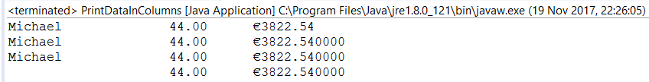

public class PrintDataInColumns {

public static void main(String[] args) {
// TODO Auto-generated method stub

String name="Michael";
double age=44;
double bankBalance=3822.54;
// System.out.printf ("%-30s %1.7f %s%n", word, etc, etc2);
System.out.printf ("%-20s %-10.2f €%.2f%n", name, age, bankBalance);
System.out.printf ("%-20s %-10.2f €%f%n", name, age, bankBalance);
System.out.printf ("%-20s %-10.2f €%f%n", name, age, bankBalance);
System.out.printf ("%-20s %-10.2f €%f%n", "" , age, bankBalance);
}
}

