Printf – Nested Ifs – For Loop – Date
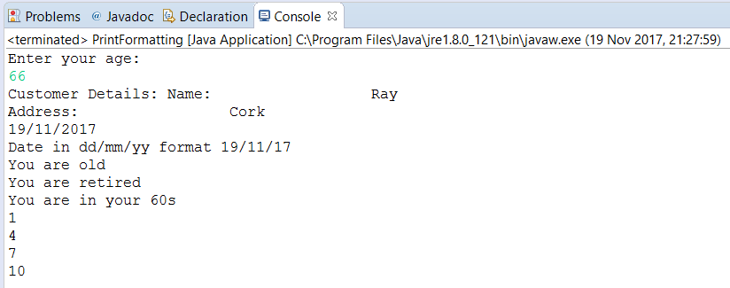
import java.util.Calendar;
import java.util.Date;
import java.util.Scanner;
public class PrintFormatting {
public static void main(String[] args) {
// Print formatting using PRINTFDateFormat dateFormat = new SimpleDateFormat("yyyy/MM/dd HH:mm:ss");
String name="Ray";
String address="Cork";
System.out.println("Enter your age: ");
Scanner in = new Scanner(System.in);
int age = in.nextInt();
in.close();
//Read more: http://www.java67.com/2016/12/7-examples-of-stringformat-and-printf.html#ixzz4yu0uwU74
System.out.printf("Customer Details: ");
System.out.printf("Name: %20s\n",name);
System.out.printf("Address: %20s%n",address);
// Create date instance and display
Calendar c = Calendar.getInstance();
System.out.format("%te/%tm/%tY%n", c, c, c);
// Import java.util.Date; to use Date
Date today = new Date();
System.out.printf("Date in dd/mm/yy format %td/%tm/%ty %n", today,today,today );
//Nested if
if (age<50) {
System.out.println("You are young");
} else {
System.out.println("You are old");
if (age>65) {
System.out.println("You are retired");
}else {
System.out.println("You are almost retired");
}
}
if (age>=80)
System.out.println("You are lucky");
else if (age>=70)
System.out.println("You are in your 70s");
else if (age>=60)
System.out.println("You are in your 60s");
else if (age>=50)
System.out.println("You are in your 50s");
else
System.out.println("You are young");
for (int counter=1;counter<=10;counter+=3) {
System.out.println(counter);
}
}
}

