Pre Skills Demo 2
Screen output

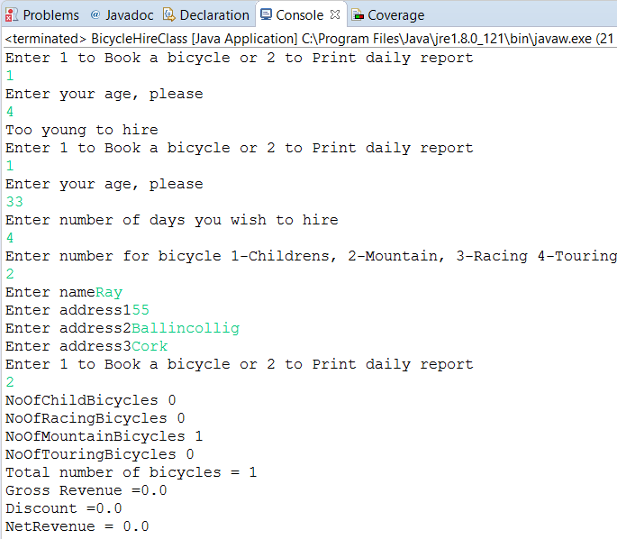

Sample Source Code which must be edited and amended

import java.util.*;

public class BicycleHireClass {

static int NoOfChildBicycles;
static int NoOfRacingBicycles;
static int NoOfMountainBicycles;
static int NoOfTouringBicycles;
static double grossRevenue, grossDiscount;

public static void main(String[] args) {
// Bicycle Hire Program

Scanner in = new Scanner(System.in);
System.out.println("Enter 1 to Book a bicycle or 2 to Print daily report");
int userChoice = in.nextInt();
while (userChoice != 2){
bookBicycle();
System.out.println("Enter 1 to Book a bicycle or 2 to Print daily report");
userChoice = in.nextInt();
}
dailyReport();
in.close();
}

static void bookBicycle(){
double childrens=5;
double mountain=7.50;
double racing=10;
double touring=12.50;
double cost=0, discount=0;

Scanner in = new Scanner(System.in);
System.out.println("Enter your age, please");
int customerAge = in.nextInt();
if (customerAge>8) {
System.out.println("Enter number of days you wish to hire");
int noOfDays = in.nextInt();
System.out.println("Enter number for bicycle 1-Childrens, 2-Mountain, 3-Racing 4-Touring");
int bicycleType = in.nextInt();
double costPerDay=0;
switch (bicycleType) {
case 1: costPerDay = childrens;
NoOfChildBicycles++;
break;
case 2: costPerDay = mountain;
NoOfMountainBicycles++;
break;
case 3: costPerDay = racing;
NoOfRacingBicycles++;
break;
case 4: costPerDay = touring;
NoOfTouringBicycles++;
break;
}
if (customerAge>18 && customerAge<24) {
if (noOfDays>10) {
cost=150;
} else {
cost=noOfDays * 15;
}
}
//Name - letters, spaces, a single quotation mark and a hyphen only
System.out.print("Enter name");
String custName = in.next();

//Address
System.out.print("Enter address1");
String custAddress1 = in.next();
System.out.print("Enter address2");
String custAddress2 = in.next();
System.out.print("Enter address3");
String custAddress3 = in.next();

//PPSN
int PPSNSize;
boolean ValidPPSN=false;
while (ValidPPSN=false) {
Scanner inp = new Scanner(System.in);
System.out.println("Enter PPSN");
String PPSN = inp.next();

for (int index = 0; index < PPSN.length()-1;index++) {
char aChar = PPSN.charAt(index);
System.out.print(aChar + " ");
System.out.print(PPSN.length());
if (Character.isDigit(aChar))
{
ValidPPSN=true;
System.out.print(ValidPPSN);
}
else {
ValidPPSN=false;
}
}
char lastChar = PPSN.charAt(7);
if (Character.isLetter(lastChar) && ValidPPSN){
ValidPPSN=true;
}
inp.close();
}

grossRevenue=+cost;
grossDiscount=+discount;
customerAge=1;
}
else {
System.out.println("Too young to hire");
}
}

static void dailyReport(){
System.out.println("NoOfChildBicycles " + NoOfChildBicycles);
System.out.println("NoOfRacingBicycles " + NoOfRacingBicycles);
System.out.println("NoOfMountainBicycles " + NoOfMountainBicycles);
System.out.println("NoOfTouringBicycles " + NoOfTouringBicycles);
System.out.println("Total number of bicycles = " + (NoOfChildBicycles + NoOfRacingBicycles + NoOfMountainBicycles + NoOfTouringBicycles));
System.out.println("Gross Revenue =" + grossRevenue);
System.out.println("Discount =" + grossDiscount);
System.out.println("NetRevenue = " + (grossRevenue - grossDiscount));
}
}

