**Java**

**For Loop**

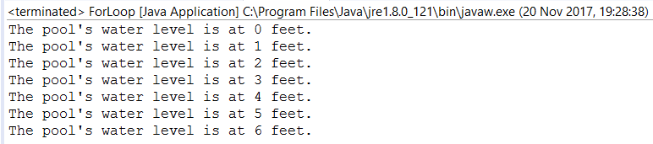

**public** **class** ForLoop {

**public** **static** **void** main(String[] args) {

**for** (**int** waterLevel=0;waterLevel < 7;waterLevel++) {

System.***out***.println("The pool's water level is at " + waterLevel + " feet.");

}

}

}

**While Loop**

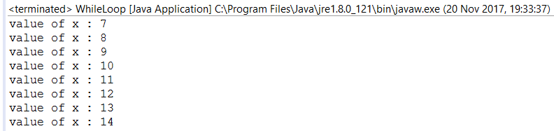

**public** **class** WhileLoop {

**public** **static** **void** main(String[] args) {

**int** x = 7;

**while**( x < 15 ) {

System.***out***.print("value of x : " + x );

x++;

System.***out***.print("\n");

}

}

}

**Do While Loop**

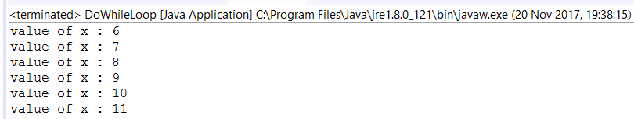

**public** **class** DoWhileLoop {

**public** **static** **void** main(String[] args) {

**int** x = 6;

**do** {

System.***out***.print("value of x : " + x );

x++;

System.***out***.print("\n");

}**while**( x < 12 );

}

}