Files – Input and Output to and from files
Create a text file containing your data using Notepad (or similar) and save with filename data.txt
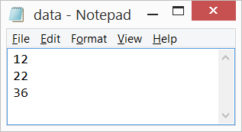
Copy and paste data.txt into your project as shown below.
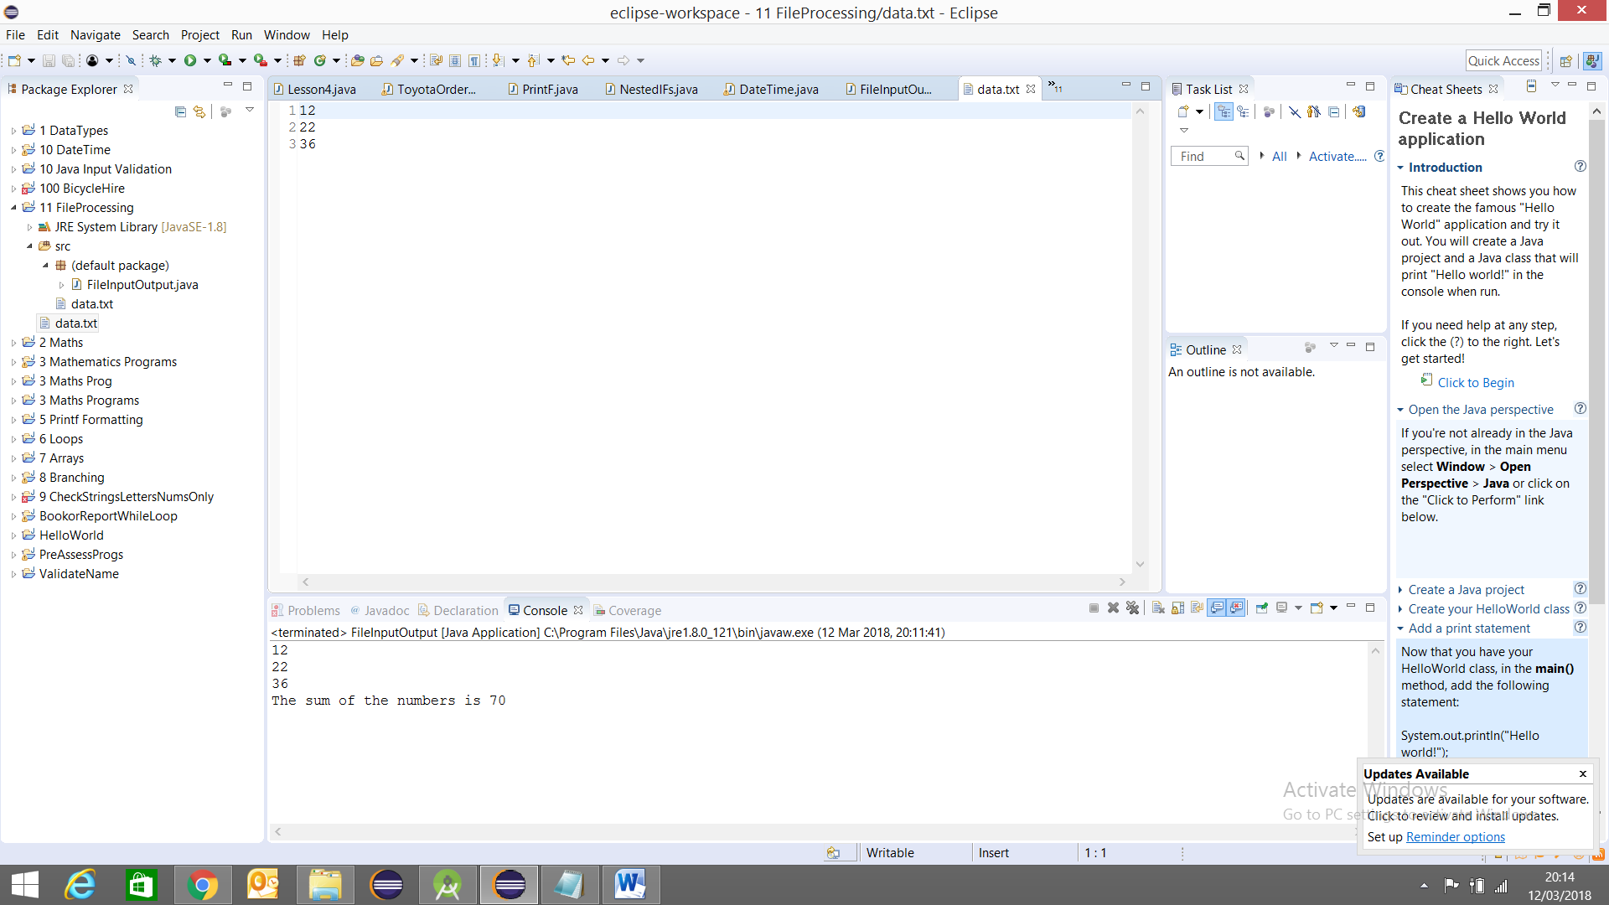
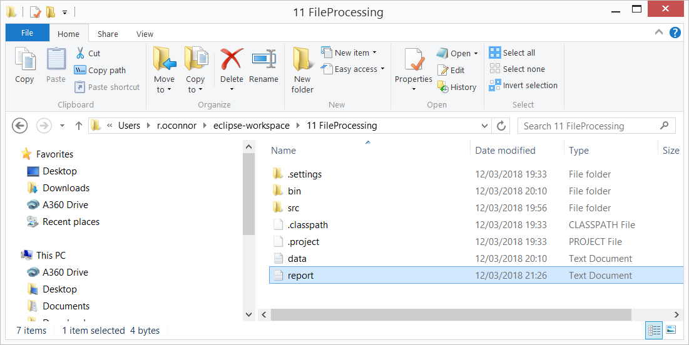

Java Source Code

import java.io.*;
import java.util.Scanner;

public class FileInputOutput {

static int num1, num2, num3,sum=0;

public static void main(String[] args) {
// Reading and writing to text files

try
{
Scanner inFile = new Scanner(new FileInputStream("data.txt"));
int number = 0;
while(inFile.hasNextLine())
{
String oneline = inFile.nextLine();
number = Integer.parseInt(oneline);
System.out.println(number);
sum = sum + number;
}
System.out.println("The sum of the numbers is " + sum);
inFile.close();
}
catch(FileNotFoundException fnfe)
{
System.out.println("File not found!!");
}

try {
PrintWriter outFile = new PrintWriter("report.txt");
outFile.println(sum);
outFile.close();
} catch (FileNotFoundException e) {
// TODO Auto-generated catch block
e.printStackTrace();
}

}
}

