Files – Input and Output to and from files
The text file is Created with filename data2.txt as shown below
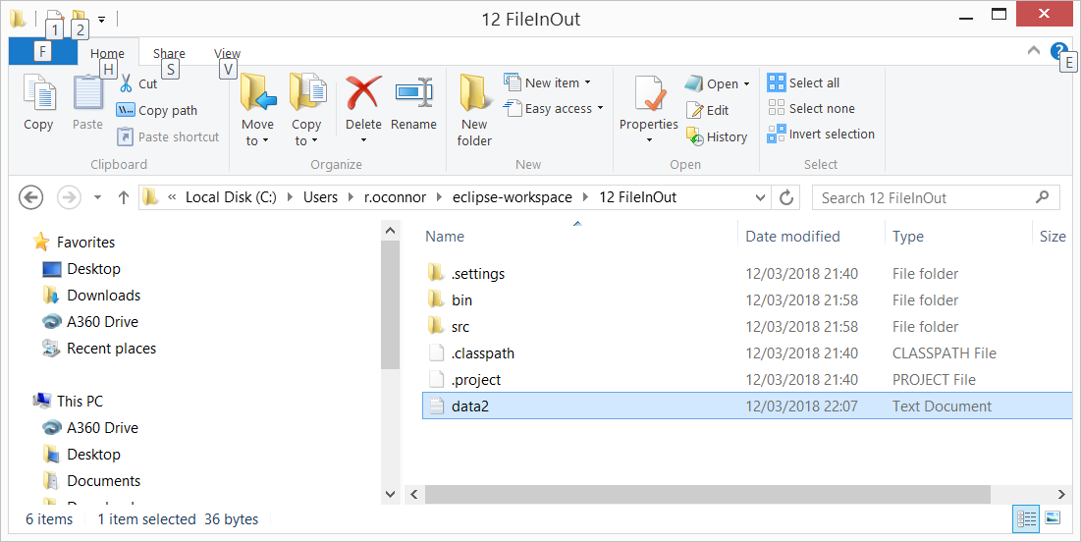
Data2.txt contains the following data as shown
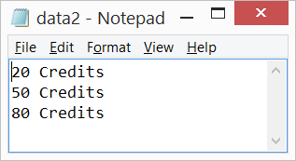

Java Source Code

import static java.lang.System.out;

import java.io.BufferedReader;
import java.io.FileReader;
import java.io.FileWriter;
import java.io.IOException;
import java.io.PrintWriter;
// import java.io.*; this would replace all lines above

public class InOutMain {

public static void main(String[] args) {
WritetoFile();
ReadfromFile();
}

static void WritetoFile() {
try {
FileWriter fw=new FileWriter("data2.txt");
PrintWriter pw=new PrintWriter(fw);
pw.println("20 Credits");
pw.println("50 Credits");
pw.println("80 Credits");
pw.close();
} catch (IOException e) {
out.println("Error!");
}
}

static void ReadfromFile() {
try {
FileReader fr=new FileReader("data2.txt");
BufferedReader br=new BufferedReader(fr);
String str;
while((str=br.readLine())!=null){
out.println(str + "\n");
}
br.close();
} catch (IOException e) {
out.println("Error!");
}
}
}

