Date – Time – Time Difference
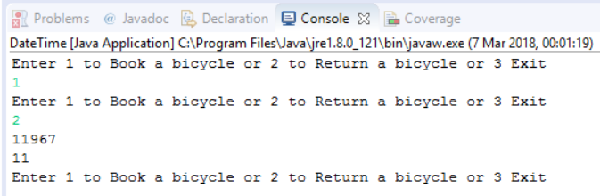

import java.util.Date;
import java.text.DateFormat;
import java.text.SimpleDateFormat;
import java.util.*;

import java.lang.System;
import java.time.Duration;
import java.time.Instant;

public class DateTime {

static Date d1, d2;

public static void main(String[] args) {

Scanner in = new Scanner(System.in);
System.out.println("Enter 1 to Book a bicycle or 2 to Return a bicycle or 3 Exit");
int userChoice = in.nextInt();
while (userChoice != 3){
switch (userChoice) {
case 1: bookBicycle();
break;
case 2: returnBicycle();
break;
}
System.out.println("Enter 1 to Book a bicycle or 2 to Return a bicycle or 3 Exit");
userChoice = in.nextInt();
}
in.close();
}

static void bookBicycle(){
d1 = new Date();

}

static void returnBicycle(){
d2 = new Date();
System.out.println(d2.getTime()-d1.getTime()); //difference in milliseconds.
System.out.println((d2.getTime()-d1.getTime())/1000);
}

}

