Java
Branching - Nested Ifs

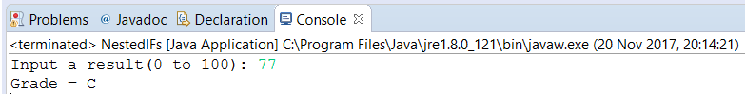

public static void main(String[] args) {

Scanner in = new Scanner(System.in);
System.out.print("Input a result(0 to 100): ");
int testResult = in.nextInt();

char grade;

if (testResult >= 90) {
grade = 'A';
} else if (testResult >= 80) {
grade = 'B';
} else if (testResult >= 70) {
grade = 'C';
} else if (testResult >= 60) {
grade = 'D';
} else {
grade = 'F';
}
System.out.println("Grade = " + grade);
}
}

