Arrays Example
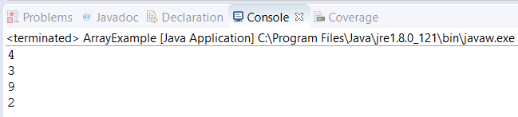

Java Source Code

public class ArrayExample {

public static void main(String[] args) {
int[] arr1 = {4,7,3,9,2};
int[] arr2 = {3,2,12,9,40,32,4};

for(int i = 0;i<arr1.length;i++) {
for(int j = 0;j<arr2.length;j++) {
if(arr1[i]==arr2[j]) {
System.out.println(arr1[i]);
}
}
}
}
}

