Java
Arrays
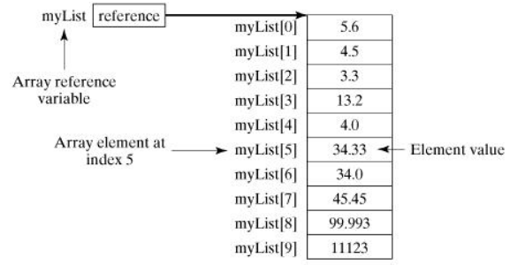
public class Array {
public static void main(String[] args) {

double[] arrNumbers = {2.1, 2.5, 5.05, 7.25};
// Print all the array elements
for (int i = 0; i < arrNumbers.length; i++) {
System.out.println(arrNumbers[i] + " ");
}
// Summing all elements
double total = 0;
for (int i = 0; i < arrNumbers.length; i++) {
total += arrNumbers[i];
}
System.out.println("Total is " + total);
// Finding the largest element
double max = arrNumbers[0];
for (int i = 1; i < arrNumbers.length; i++) {
if (arrNumbers[i] > max) max = arrNumbers[i];
}
System.out.println("Max is " + max);
}
}
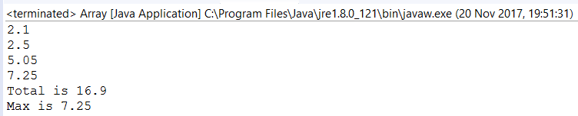
Short Code
public class TestArray {
public static void main(String[] args) {
double[] myList = {1.9, 2.9, 3.4, 3.5};
// Print all the array elements
for (double element: myList) {
System.out.println(element);
}
}
}

