6.3 Solve practical, simple problems using appropriate trigonometric formulae and terminology, including the sine, cosine and tangent ratios for right angled triangles, area of triangle=1/2absin C, Sine Rule, Cosine Rule
Working with right angled triangles
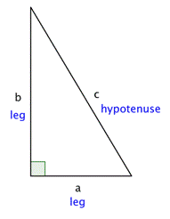
The Pythagorean Theorem
If a and b are the lengths of the legs of a right triangle and c is the length of the hypotenuse, then the sum of the squares of the lengths of the legs is equal to the square of the length of the hypotenuse.
$$a^{2}+b^{2}=c^{2}$$

Solving triangles
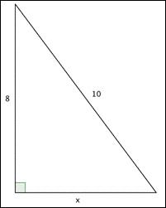
$$x^{2}+8^{2}={10}^{2}$$
Therefore x=6
Solving triangles using trigonometry

SOHCAHTOA

$\sin{α}(sine)= \frac{opposite}{hypotenuse}$ $\cos{α} (cosine)= \frac{adjacent}{hypotenuse}$ $\tan{α} (tangent)= \frac{opposite}{adjacent}$
We can find all the angles and lengths of the sides of a triangle using the formula above.
Exercise
- Calculate the size of each angle for each of the following
- Find the length of side of the triangle in the following

