6.2 Define sine, cosine and tangent functions as related to the unit circle
The Unit Circle
The Unit Circle has a centre (0, 0) with radius of 1 unit.
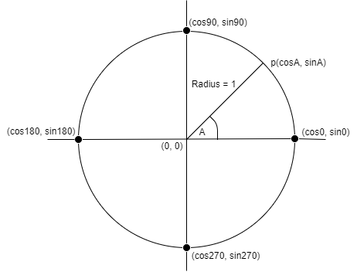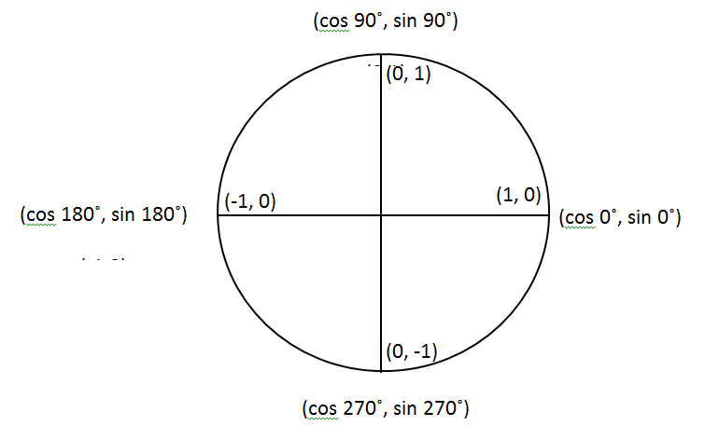

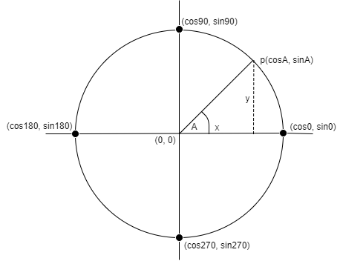

SOHCAHTOA

$\sin{α}(sine)= \frac{opposite}{hypotenuse}$ $\cos{α} (cosine)= \frac{adjacent}{hypotenuse}$ $\tan{α} (tangent)= \frac{opposite}{adjacent}$
Let p(x, y) be any point on the circle, as shown above.
p(cos A , sin A)
$cosA= \frac{x}{1} , therefore x=cosA$
$sinA= \frac{y}{1} , therefore y=sinA$
Remember: The co-ordinates of any point on the unit circle are (cos A, sin A)
From the Unit Circle we can calculate the following quite easily
Sin, Cos and Tan of 0˚, 90˚, 180˚, 270˚ and 360˚.

The unit circle is particularly useful when finding the sine or cosine of the angles 0˚, 90˚, 180˚, 270˚ and 360˚. The diagram below shows the values of sine and cosine of the angles mentioned above.
(cos 90˚, sin 90˚)
(0,1)

(0, 1)
(0,1)

(-1, 0)
(0,1)
(1, 0)
(0,1)
(cos 0˚, sin 0˚)
(cos 180˚, sin 180˚)
(-1,0)

(0, -1)
(0,1)
(cos 270˚, sin 270˚)
(0,-1)

From the Unit Circle above:
cos 0˚ = 1 cos 90˚ = 0 cos 180˚ = -1 cos 270˚ = 0
sin 0˚ = 0 sin 90˚ = 1 sin 180˚ = 0 sin 270˚ = -1

Note: sine and cosine of 0º are the same as sine and cosine 360˚.
From Log/Mathematics Tables tan Ө = $\frac{sinӨ}{cosӨ}$ , we can also use the unit circle to find the value of the tangent of the angles 0˚, 90˚, 180˚, 270˚ or 360˚.
Thus
- tan 0˚ = $\frac{sin0}{cos0}$ = $\frac{0}{1}$ = 0

- tan 90˚ = $\frac{1}{0}$ … (not a real number)

- tan 180˚ = $\frac{0}{-1}$ = 0

- tan 270˚ = $\frac{-1}{0}$ … (not a real number)

The Four Quadrants

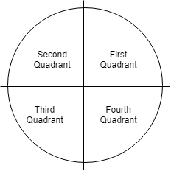
The x-axis and y-axis divide a full rotation of 360˚ into 4 quadrants
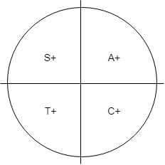
The diagram shows the positive ratios in the four quadrants.
(i) In the 1st quadrant, all (A) positive.
(ii) In the 2nd quadrant, sin (S) only positive.
(iii) In the 3rd quadrant, tan (T) only positive.
(iv) In the 4th quadrant, cos (C) only positive.

The unit circle below shows an angle of Ө in each of the four quadrants. The signs shown in each triangle determine whether a ratio is positive or negative. The signs of the sine, cosine and tangent of an angle in each quadrant are shown.

Exercises
What will be the sign for each of the following?
- Cos 46º =
- Sin 110 º =
- Tan 300 º =
- Cos 125º =
- Sin 295 º =
- Tan 92 º =

_
Using Log Tables to calculate sin/cos/tan
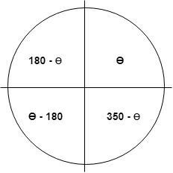

Finding the Ratio of an Angle between 90˚ and 360˚
A calculator will give you the sine, cosine and tangent of any angle including the negative sign, if it exists. If Mathematics Tables are used these steps should be followed:
- Determine in which quadrant the angle lies.
- Hence, state if the sign of the ratio is positive or negative.
- Determine the angle (< 90˚) between the rotated line and the x-axis.
- Read the required ratio of the angle from your tables and insert the sign from (ii) above.

Exercises
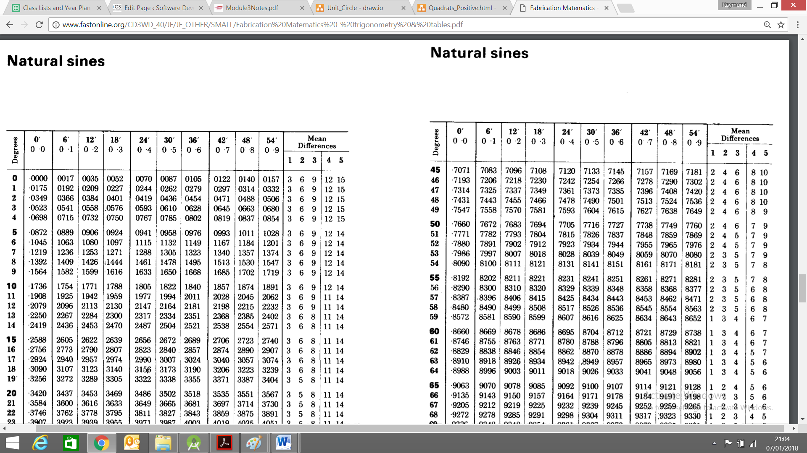
Calculate each of the following using Log Tables
- sin 225º = sign will be + because it is in second quadrant, 225 – 180 = 45, lookup log table for sin45º = –0.7071
- tan 300º = ? (sign will be -), 360-300=60, tan 60 = -1.7321)
- cos 160 º = ? (sign will be -), 180-160=20, cos 20 = -0.9397)
