6.2.1 Log table, formula and angles
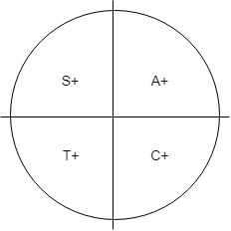 | 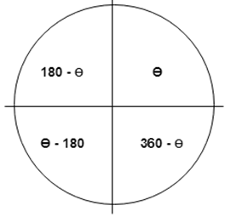
The diagram shows the positive ratios in the four quadrants.
(i) In the 1st quadrant, all (A) positive
(ii) In the 2nd quadrant, sin (S) only positive
(iii) In the 3rd quadrant, tan (T) only positive
(iv) In the 4th quadrant, cos (C) only positive

Exercises – solutions on next page
- If$\cos{A= -0.5}$. $0°≤A ≤360°.$ Find two possible values for A.
- If$\sin{B= -0.2588}$. $0°≤A ≤360°.$ Find two possible values for B.
- If$\sin{C= 0.0872}$. $0°≤A ≤360°.$ Find two possible values for C.
- If$\cos{D= 0.9848}$. $0°≤A ≤360°.$ Find two possible values for D.

Solutions
1 $\cos{A= -0.5}$
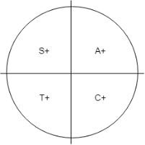
We know the angle must be in second or third quadrant from diagram above  Using cos pages in Log Tables  0.5 gives us 60º | From diagram above  180 – 120 = 60  or  240 – 180 = 60  Therefore A = 240º or 120º

2 $\sin{B= -0.2588}$
We know the angle must be in third or fourth quadrant from diagram above  Using sin pages in Log Tables  0.2588 gives us 15º | From diagram above  195 – 180 = 15  or  360 – 345 = 15  Therefore A = 345º or 195º

